Goonhavern Primary School- Music
TOPIC: How does music teach us about our neighbourhood? | YEAR: 2 | STRAND: Inventing a musical story

What should I know already? | What will I know by the end of the unit?
I am able to sing songs and make pieces of music using a range of sounds. I can improvise on a glockenspiel or xylophone. I can recognise high and low notes. I can play and sing songs by ear. I can recognise rests and create melodies using music technology. I can explain what the words ‘tempo’ and ‘dynamics’ are. | I can find and try to keep a steady beat.
 | I can copyback rhythms on untuned percussion instruments and make up rhythms for other people to copyback.
 | I can read and perform music written as standard notation.
 | I can recognise and sing low and high notes.
 | I can explain my thoughts, feelings and emotions towards songs.
 | I can sing in a group and develop confidence to sing a solo.
 | I can perform my compositions to others.
School Values
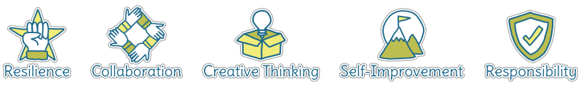
Five Ways to Wellbeing
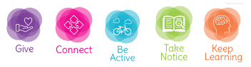

Vocabulary
Dynamics | How loud or quiet a piece of music is.
Composition | To make up a piece of music.
Melody | A sequence of single notes that makes a musical tune.
Tempo | How fast or slow a piece of music is.
Notes | A written sign to represent the pitch and duration within music.
Beat | A regular, rhythmic (and sometimes strong) sound.
Steady beat | A consistent pulse within the music.
Rests | A pause within a piece of music (worth one whole note value).
Solo | Singing alone.

Image/diagram that helps me to articulate my knowledge/understanding | Investigate!

