Goonhavern Primary School- Music
TOPIC: How do we make friends when we sing together? | YEAR: 1 | STRAND: Introducing beat

What should I know already? | What will I know by the end of the unit?
I am able to sing a range of well-known nursery rhymes and songs. I can perform songs, rhymes, poems and stories with others, and – when appropriate – try to move in time with music. | I can improvise using the notes C, D and E on a glockenspiel or xylophone.
 | I can move to the beat and sing along to songs as a group.
 | I can recognise and clap back quavers, crotchets and minims (as short short, short and long notes and colours).
 | I can recognise and sing back high and low notes.
 | I can compose a simple melody using between two and five notes.
 | I can create a graphic score to record my composition.
School Values
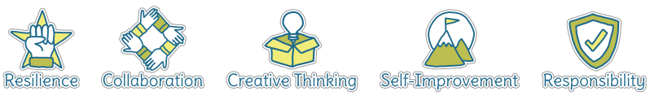
Five Ways to Welbeing
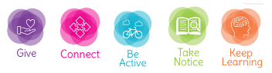

Vocabulary
Improvise | To create and perform without preparation.
Composition | To make up a piece of music.
Quavers | A musical note worth half a beat.
Crotchets | A musical note worth one full beat.
Minims | A musical note worth two full beats.
Melody | A sequence of single notes that makes a musical tune.
Graphic Score | An image or picture with symbols to represent notes.
Notes | A written sign to represent the pitch and duration within music.
Beat | A regular, rhythmic (and sometimes strong) sound.

Image/diagram that helps me to articulate my knowledge/understanding | Investigate!
What piece can you create using the notes C, D and E on a glockenspiel or xylophone?
What rhythms can you make using quavers, crotchets and minims when clapping?

