Goonhavern Primary School- Music
TOPIC: How does music help us to make friends? | YEAR: 2 | STRAND: Exploring Simple Patterns

What should I know already? | What will I know by the end of the unit?
I am able to sing songs and make pieces of music using a range of sounds. I can improvise on a glockenspiel or xylophone. I can recognise high and low notes. I can play and sing songs by ear. I can recognise rests and create melodies using music technology. I can compose pieces of music which start and end on the same note. | I can play a melody on a tuned instrument by ear.
 | I can explain the meanings of the words tempo and dynamics.
 | I can keep and recognise a steady beat.
 | I can sing in a group and develop confidence to sing a solo.
 | I can compose an 8-bar melody using 3 or 5 notes.
School Values
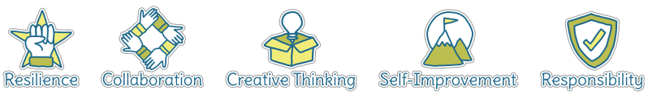
Five Ways to Wellbeing
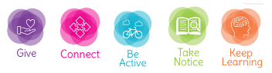

Vocabulary
Dynamics | How loud or quiet a piece of music is.
Composition | To make up a piece of music.
Quavers | A musical note worth half a beat.
Crotchets | A musical note worth one full beat.
Minims | A musical note worth two full beats.
Melody | A sequence of single notes that makes a musical tune.
Tempo | How fast or slow a piece of music is.
Notes | A written sign to represent the pitch and duration within music.
Beat | A regular, rhythmic (and sometimes strong) sound.
Rests | A pause within a piece of music (usually a full one beat note).

Image/diagram that helps me to articulate my knowledge/understanding | Investigate!

