Goonhavern Primary School
TOPIC: PE | YEAR: 1 | STRAND: Multi Skills

What should I know already? | What will I know by the end of the unit?
From EYFS:  - Experiments with different ways of moving.  - Jumps off an object and lands appropriately.  - Negotiates space successfully when playing racing and chasing games with other children, adjusting speed or changing direction to avoid obstacles.  - Travels with confidence and skill around, under, over and through balancing and climbing equipment.  - Shows increasing control over an object in pushing, patting, throwing, catching or kicking it.  - Early Learning Goal Children show good control and co-ordination in large and small movements. They move confidently in a range of ways, safely negotiating space | That exercise can make my heart rate faster
 | That exercise can make my body change, (rosy cheeks, breathless, warmer, sweat)
 | How to move at different speeds, the difference between, walk, jog, run and sprint
 | How to catch different size balls
 | How to get ready to catch a ball
 | How to roll a ball
 | How to throw a ball to a partner
 | How to catch and throw a bean bag
 | How to hop in a straight line/zig zag line and change direction
 | How to skip in a straight line/zig zag line and change direction
 | How to warm up and down and why it’s important
School Values
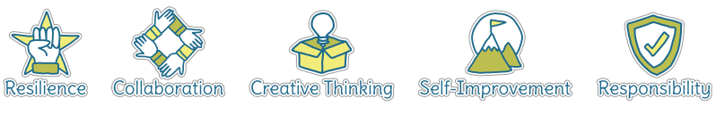
Five Ways to Wellbeing


Vocabulary
Heart rate | How fast your heart is beating
Walk | Moving at a normal pace
Jog | Running at a slow pace
Run | Lifting your legs higher with longer strides
Sprint | Running at your top speed
Roll | When an object stays on the ground after being pushed
Hop | Moving on one leg/foot
Skip | Always keeping one foot off the ground
Direction | The way you are going
Warm up/down | Getting our heart rate up and down

Image/diagram that helps me to articulate my knowledge/understanding | Investigate!
-Recognising the link between exercise and heart rate. Feel heart after different types of exercise, which makes it go fast?
-introduce to warm up games and cool down stretches and talk about importance
-Introduce to running, basic ball skills and basic types of movement
-Finish unit with obstacle course incorporating all new skills learnt

