Goonhavern Primary School Physical Education
TOPIC: Invasion Games | YEAR: 1 | STRAND: General Skills

What should I know already? | What will I know by the end of the unit?
From EYFS:  - Experiments with different ways of moving.  - Jumps off an object and lands appropriately.  - Negotiates space successfully when playing racing and chasing games with other children, adjusting speed or changing direction to avoid obstacles.  - Travels with confidence and skill around, under, over and through balancing and climbing equipment.  - Shows increasing control over an object in pushing, patting, throwing, catching or kicking it.  - Early Learning Goal Children show good control and co-ordination in large and small movements. They move confidently in a range of ways, safely negotiating space | How to ‘catch’/receive a ball that has been rolled.
 | How to throw a ball with two hands (chest/shoulder pass)
 | How to prepare to catch a ball
 | How to to catch a ball (cushioning the ball with my hands)
 | One or two tactics for attacking and defending
 | How to push a ball with a hockey stick
 | How to receive a ball with a hockey stick
 | How to kick a ball with the side of your foot
 | How to receive a ball with the side of your foot
School Values
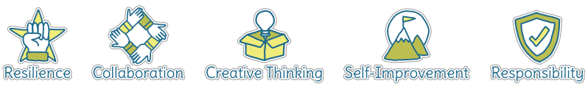
Five Ways to Wellbeing
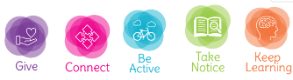

Vocabulary
Throw | To release a ball/object from your hands, normally aiming for a teammate or a target.
Receive | To catch or ‘get’ a ball or object that someone has passed to you.
Chest pass | A two-handed pass to a teammate that starts at the chest.
Shoulder pass | A pass to a teammate that starts by next to the shoulder.
Hand-eye coordination | The link between what you see and how your hands move (for example when catching a ball).
Attacking | Trying to score against the opposing
Defending | Trying to stop the opposing team from scoring
Tactic | Ideas to help you win a game.

Image/diagram that helps me to articulate my knowledge/understanding | Possible Games/Ideas
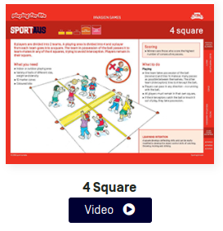  Sport Aus - Cards and Videos | Ideas from Sport Aus - Cards and Videos  - 4 Square  - Names (varying ball size/shape and equipment for example: using hockey equipment).  - Target and intercept (link with maths skills)  Build towards dodgeball and benchball style games. The final session could be in the form of a tournament.

