Goonhavern Primary School
TOPIC: PE | YEAR: 1 | STRAND: Gymnastics

What should I know already? | What will I know by the end of the unit?
From EYFS:  - Experiments with different ways of moving.  - Jumps off an object and lands appropriately.  - Negotiates space successfully when playing racing and chasing games with other children, adjusting speed or changing direction to avoid obstacles.  - Travels with confidence and skill around, under, over and through balancing and climbing equipment.  - Shows increasing control over an object in pushing, patting, throwing, catching or kicking it.  - Early Learning Goal Children show good control and co-ordination in large and small movements. They move confidently in a range of ways, safely negotiating space | Respond to instructions and commands
 | Move between mats and small apparatus and change the speed of movement.
 | Be still in different body shapes and balances
 | How to combine different ways of travelling.
 | Handle apparatus safely.
 | Recognise how it feels when the body is tense.
 | How to balance using different body parts
School Values
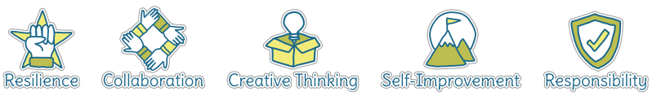
Five Ways to Wellbeing
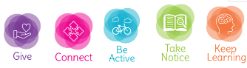

Vocabulary
Apparatus | Equipment we use in gymnastics
Balance | Being in a steady position without falling
Travelling | How you move your body
Tense | When a muscle feels tight
Strength | How strong you feel
Core Strength | Using the middle part of your body for strength
Coordination | Using different parts of the body at once smoothly

Image/diagram that helps me to articulate my knowledge/understanding | Investigate!
See links ---> | -How can I balance on different body parts?  -How can I balance when on different apparatus?  -What helps me balance?  -How long can I hold a balance?  -How many ways to travel? Difference between low and high travel?  What’s Ahead?  https://www.sportaus.gov.au/__data/assets/pdf_file/0003/704019/Whats-ahead.pdf  Stone, Bridge and Tree  https://www.sportaus.gov.au/__data/assets/pdf_file/0005/703994/Stone-bridge-and-tree.pdf

