Goonhavern Primary School- SUBJECT
TOPIC: PE | YEAR: 1 | STRAND: Dance

What should I know already? | What will I know by the end of the unit?
From EYFS:  - Experiments with different ways of moving.  - Jumps off an object and lands appropriately.  - Negotiates space successfully when playing racing and chasing games with other children, adjusting speed or changing direction to avoid obstacles.  - Travels with confidence and skill around, under, over and through balancing and climbing equipment.  - Shows increasing control over an object in pushing, patting, throwing, catching or kicking it.  - Early Learning Goal Children show good control and co-ordination in large and small movements. They move confidently in a range of ways, safely negotiating space | How to move to music’s rhythm and pace
 | How to copy, remember and perform simple dance moves
 | How to move around space safely
 | How to dance in personal space and wider space
 | How to ‘wiggle, shake, swing, twist, and spin’ the body and different parts of the body
 | Move feet and hands simultaneously
 | How to make a shape and hold it
 | How to make low and high level shapes
School Values
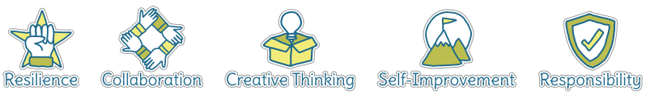
Five Ways to Wellbeing
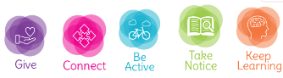

Vocabulary
Rhythm | The speed and pattern of the music
Pace | The speed
Perform | To show to an audience
Personal space | The space around your body
Wider space | The space in the room
Wiggle | Move up or down or side to side
Twist | Turn part of the body whilst the rest stays still
Swing | Smooth movement in one direction
Spin | Turn in a circle
Simultaneously | At the same time

Image/diagram that helps me to articulate my knowledge/understanding | Investigate!
-How would we move to different music and why?
-Explore different genres of music and have free flow dance to the songs-move to how it makes you feel
-Create routines linked to learning in the classroom (e.g. stories you are reading)
-Create short sequences as a class, in groups and in pairs
-End with a performance for parents to watch either in school or on tapestry

