Goonhavern Primary School
TOPIC: PE | YEAR: 2 | STRAND: Striking and Fielding

What should I know already? | What will I know by the end of the unit?
Show spatial awareness & awareness of others in running, chasing & avoiding games  Developed confidence catching a ball with minimal reaction time  How to roll a ball at the right speed to reach a target  How to throw a ball to a partner from varying distances  Aim a beanbag accurately to a target | The difference between feilding and striking
 | A bowler is someone who throws the ball to the batter
 | How to throw a ball whilst moving
 | How to track a ball and receive it
 | How to return a ball with accuracy
 | How to hit or strike the ball into spaces
 | Develop throwing power and technique
 | How to consider the best place to stand when feilding
 | How to work in a team to keep opposing team’s points down
 | How to create strategies in teams to keep opposing team’s points down
 | How to work cooperatively and competitively with a partner
School Values
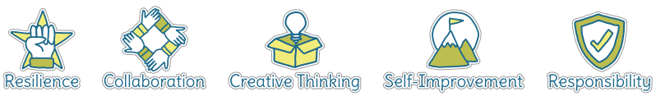
Five Ways to Wellbeing


Vocabulary
Feilding | To catch or stop the ball hit by the batter
Striking | To hit the ball
Bowler | Throwing the ball to the batter
Batter | Hitting the ball with a bat
Track | Follow
Strategy | A plan
Cooperatively | Working together
Competitively | Working against others to win
Team work | Working successfully in a team
Accuracy | Aiming for a certain place

Image/diagram that helps me to articulate my knowledge/understanding | Investigate!
Catching challenge:
https://www.sportaus.gov.au/__data/assets/pdf_file/0007/703897/catching-Challenge.pdf

-Practise skills (catching, passing, batting) and build up to rounders or quik cricket games in small groups at the end of the unit
-Try batting with different shape bats, progress some more able children to using wooden rounders bats.

