Goonhavern Primary School
TOPIC: PE | YEAR: 2 | STRAND: Multi-Skills

What should I know already? | What will I know by the end of the unit?
-That exercise can make my heart rate faster  -That exercise can make my body change, (rosy cheeks, breathless, warmer, sweat)  -How to move at different speeds, the difference between, walk, jog, run and sprint  -How to catch different size balls  -How to get ready to catch a ball  -How to roll a ball  -How to throw a ball to a partner  -How to catch and throw a bean bag  -How to hop in a straight line/zig zag line and change direction  -How to skip in a straight line/zig zag line and change direction  -How to warm up and down and why it’s important | That the harder I work the faster my heart will pump because my muscles need more oxygen
 | How to control my breathing when exercising
 | How to change direction at different speeds
 | How to vary my speed for the distance I need to cover
 | How to vary my speed for inclines and declines
 | Show spatial awareness & awareness of others in running, chasing & avoiding games
 | Developed confidence catching a ball with minimal reaction time
 | How to roll a ball at the right speed to reach a target
 | How to throw a ball to a partner from varying distances
 | Aim a beanbag accurately to a target
 | Perform a variety of movements (including hop and skip from year 1) in a straight line, zig zag, changing direction and navigating around obstacles
 | Develop jumping technique and knowing how to land safely
 | Show which muscles are being used when carrying out different activities and stretches in the cooldown
School Values
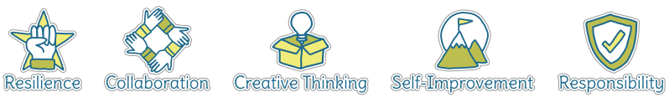

Five Ways to Wellbeing
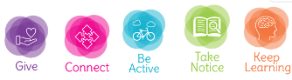

Vocabulary
Muscles | Part of our body that helps us move and gives us strength
Oxygen | AIr we need
speed | How fast you are moving
Distance | The length of space you have covered
Incline | Uphill
Decline | Downhill
Spatial awareness | Finding space around you to move in
Avoiding | Moving away from something/someone
Reaction time | Time it takes to be ready
Navigating | Finding a way
Obstacles | Things that might stop us
Stretches | Gently moving muscles

Image/diagram that helps me to articulate my knowledge/understanding | Investigate!
-Explore different breathing techniques that can help us when we are out of breath
-Discuss when being out of breath is good/bad. What makes us out of breath?
-Play games that involve running at speeds, in different directions and space finding (e.g. tag, stuck in the mud, bulldog)
Corkscrew tag
https://www.sportaus.gov.au/__data/assets/pdf_file/0006/703905/Cork-screw-tag.pdf
Pirate’s Gold
https://www.sportaus.gov.au/__data/assets/pdf_file/0008/703979/Pirates-gold.pdf
-Have a go at relay running up and down hill
-Once ball skills have been practised, develop the skills through team games such as bench ball and dodgeball
-Create obstacle course that involves all skills learnt over the unit

