Goonhavern Primary School Physical Education
TOPIC: Invasion Games | YEAR: 2 | STRAND: Hockey

What should I know already? | What will I know by the end of the unit?
From Year 1:  - How to ‘catch’/receive a ball that has been rolled.  - How to throw a ball with two hands (chest/shoulder pass)  - How to prepare to catch a ball  - How to to catch a ball (cushioning the ball with my hands)  - One or two tactics for attacking and defending  - How to push a ball with a hockey stick  - How to receive a ball with a hockey stick  - How to kick a ball with the side of your foot  - How to receive a ball with the side of your foot | Simple rules of a hockey game
 | Improving the accuracy of passing a ball with a hockey stick and aiming for target
 | Increase the distance of passing a ball with a hockey stick
 | Improving the consistency of pass and receiving
 | How to find space when on the attacking team
 | How to intercept the ball when defending
 | How to dribble a hockey ball and keep it under control in a straight line
 | How to dribble a hockey ball and keep it under control in a zig zag line
 | How to change speed and direction during a game
 | How to defend by ‘marking’ an opponent
School Values
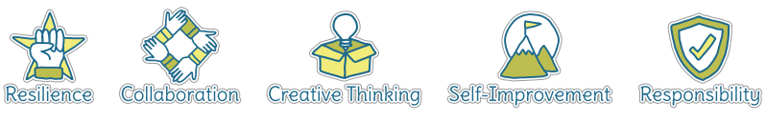
Five Ways to Wellbeing
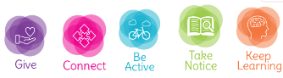

Vocabulary
Accuracy | How close you can get the ball/object to where you want it to go.
Receive | To catch or ‘get’ a ball or object that someone has passed to you.
Chest pass | A two-handed pass to a teammate that starts at the chest.
Shoulder pass | A pass to a teammate that starts by next to the shoulder.
Hand-eye coordination | The link between what you see and how your hands move (for example when catching a ball).
Attacking | Trying to score against the opposing
Defending | Trying to stop the opposing team from scoring
Tactic | Ideas to help you win a game.
Intercept | To block the ball/object from reaching your opponent
Distance | How far something is from one point. For example, the distance you can throw a ball.
Consistency | Regularly being able to do something. For example, consistently catch a ball when it is thrown to you.

Image/diagram that helps me to articulate my knowledge/understanding | Possible Games/Ideas
Ideas from Sport Aus - Cards and Videos
- 4 Square
- Names (varying ball size/shape and equipment for example: using hockey equipment).
- Target and intercept (link with maths skills)
ADAPT these games into using hockey stick and ball.

The final session could be in the form of a hockey tournament.

