Goonhavern Primary School
TOPIC: PE | YEAR: 2 | STRAND: Gymnastics

What should I know already? | What will I know by the end of the unit?
-Respond to instructions and commands  -Move between mats and small apparatus and change the speed of movement.  -Be still in different body shapes and balances  -How to combine different ways of travelling.  -Handle apparatus safely.  -Recognise how it feels when the body is tense.  -How to balance using different body parts |  | How to create a short sequence of movements with a beginning, middle and end
 |  | Create more challenging shapes and balances using different body parts
 |  | How to safely perform these shapes/balances on apparatus
 |  | How to safely and creatively travel low and high, changing pace/direction and across apparatus
 |  | How to smoothly transition from a movement into a balance
 |  | To know and create the body shapes: Star, Tuck, Pike, Arch and Dish
Know different types of rolling:
Pencil (sausage), Hedgehog (forward), Rocking (onto back) Rocking to stand with help

 |  | How to safely perform straight jumps off apparatus and land with a good technique
School Values
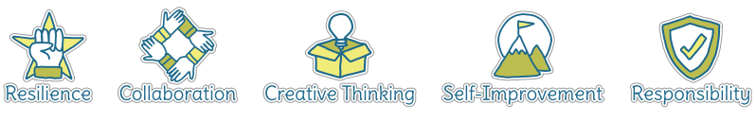

Five Ways to Wellbeing
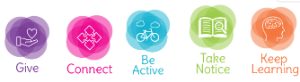

Vocabulary
Sequence | An order of movements
balance | Holding a position
Apparatus | Equipment we can climb or travel on
Travel | How we move
Transition | Changing
Star | Arms and legs spread out
Tuck | Legs and arms folded into chest
Pike | Bent at the waist with legs out straight
Arch | Back creating a curve
Dish | Long sit and then roll back bringing legs up
Straight | Vertical line
Curved | A position with a bend

Image/diagram that helps me to articulate my knowledge/understanding | Investigate!
See links ------> | Frozen Tag:  https://www.sportaus.gov.au/__data/assets/pdf_file/0010/703927/Frozen-tag.pdf  Spaghetti Bodies:  https://www.sportaus.gov.au/__data/assets/pdf_file/0010/703990/Spaghetti-bodies.pdf  Shapes in spaces:  https://www.sportaus.gov.au/__data/assets/pdf_file/0006/703986/Shapes-in-space.pdf  Stone, Bridge and Tree  https://www.sportaus.gov.au/__data/assets/pdf_file/0005/703994/Stone-bridge-and-tree.pdf  Build up skills to being able to perform a sequence of movements in partners or small groups.  More able children may be confident to do it individually

