Goonhavern Primary School
TOPIC: PE | YEAR: 2 | STRAND: Dance

What should I know already? | What will I know by the end of the unit?
-How to move to music’s rhythm and pace  -How to copy, remember and perform simple dance moves  -How to move around space safely  -How to dance in personal space and wider space  -How to ‘wiggle, shake, swing, twist, and spin’ the body and different parts of the body  -Move feet and hands simultaneously  -How to make a shape and hold it  -How to make low and high level shapes | Move accurately in time with music’s rhythm and pace
 | How to show expressive qualities in dance moves
 | Show emotions and energy levels through dance
 | How to smoothly transition from each move
 | Perform different movements simultaneously with opposite hands and feet
 | Remember and repeat short dance sequences
 | How to choose movements that suit the music and dance idea
 | Create short sequences with a beginning, middle and ending
 | Express how different dance performances you’ve watched make you feel and why
School Values
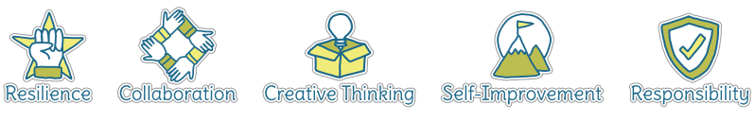
Five Ways to Wellbeing
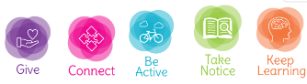

Vocabulary
Rhythm | Pattern and pace of music
pace | The speed
Energy levels | How much power
Emotion | feelings
Smooth | Without stopping/hestiating
Transition | Changing
Simultaneously | At the same time
Sequence | A collection of movements in a certain order
Control | Being able to manipulate
Pattern | The sequence where everything is the same

Image/diagram that helps me to articulate my knowledge/understanding | Investigate!
Create, perform and share short dances based on themes such as: • clowns – funny walking patterns, balancing, tumbling, jumping, falling • penguins – huddling, flapping, waddling • folk dance patterns – dancing in a circle, skipping to the centre and out, clapping and stamping a pattern on the spot, walking backwards and forwards in a chain.
Link dance to learning in the classroom (e.g. a book you are reading)
Build up to a performance for parents, school or on tapestry
Explore different music and how it make syou feel
Explore emotions and how we can show these through dance

