Goonhavern Primary School
TOPIC: PE | YEAR: 2 | STRAND: Athletics

What should I know already? | What will I know by the end of the unit?
-How to throw an object underarm  -How to throw an object overarm  -Improve distance of a throw using more power  -Throw towards a target with increasing accuracy  -Perform different types of jumps: for example, two feet to two feet, two feet to one foot, one foot to same foot or one foot to opposite foot.  -Perform a short jumping sequence.  -Jump as high as possible.  -Jump as far as possible.  -Land safely and with control.  -Vary their pace and speed when running.  -Run with a basic technique over different distances.  -Jog in a straight line. Change direction when jogging.  -Sprint in a straight line. Change direction when sprinting. | Best technique for throw a variety of objects (e.g. javelin, football, beanbag, tennis ball, howler)
 | How to throw accurately to hit low, high, distant and moving targets
 | How to perform and compare different types of jumps: for example, two feet to two feet, two feet to one foot, one foot to same foot or one foot to opposite foot.
 | How to combine different jumps together with some fluency and control.
 | How to jump for distance from a standing position with accuracy and control
 | How to run at different paces, describing the different paces.
 | How to use a variety of different stride lengths.
 | How to begin to select the most suitable pace and speed for distance.
 | How to vary the speed and direction in which they are travelling.
 | How to run with basic techniques following a curved line.
 | Be able to maintain and control a run over different distance
School Values
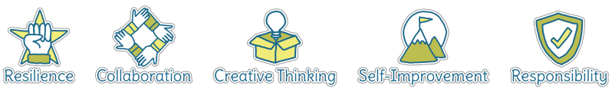
Five Ways to Wellbeing


Vocabulary
Javelin | A light spear thrown in sport
howler | A rocket shaped object thrown in sport
Overarm | Arm swings above your head
Underarm | Arm swings below your hip
Long jump | Jumping as far forwards as you can
Triple jump | 3 steps before the jump is performed
Standing jump | Jumping from a standing position
Stride | The length of the step you take
speed | How fast you are moving
Distance | How far you have travelled
Consistency | Keeping something the same

Image/diagram that helps me to articulate my knowledge/understanding | Investigate!
See Links ---> | Build up to sports day and incorporate the events into PE lessons.  Practise long and short distances. Including relay racing.  Bullseye game: https://www.sportaus.gov.au/__data/assets/pdf_file/0005/703895/Bullseye.pdf  Hit the Target Game:  https://www.sportaus.gov.au/__data/assets/pdf_file/0011/703937/Hit-the-target.pdf  Get the Beanbag:  https://www.sportaus.gov.au/__data/assets/pdf_file/0003/703929/Get-the-bean-bag.pdf

