Goonhavern Primary School
TOPIC: PE | YEAR: 3 | STRAND: Swimming

What should I know already? | What will I know by the end of the unit?
-Water safety at the beach  -Water safety at a pool | move in the pool (for example, jump, walk, hop, and spin, using swimming aids and/or support)
 | float and move with and without swimming aids
 | propel themselves in water using different swimming aids, arms and leg actions and basic strokes.
 | Tread water for a sustained period of time
 | Begin to learn some strokes (front crawl, backstroke, breaststroke)
 | Know how to respond if themselves or someone else is in danger
 | Know how to act safety around the edge of a pool
School Values
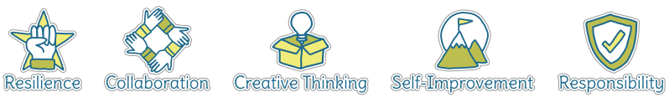
Five Ways to Wellbeing
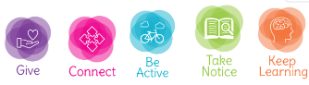

Vocabulary
Float | Stay above water
Swimming aids | Objects that help us float
Floats | Objects that help us float
Stroke | Arm movement in the water
Tread water | Kicking your legs to stay above water
Front crawl | a style of swimming in which the swimmer faces downwards and moves their arms alternately.
Backstroke | A style of swimming performed on your back
Breaststroke | A style of swimming where you arms move in and out from your breast
LIfeguard | A person who keeps us safe at a swimming pool

Image/diagram that helps me to articulate my knowledge/understanding | Investigate!

