Goonhavern Primary School
TOPIC: PE | YEAR: 3 | STRAND: Net Games (Tennis)

What should I know already? | What will I know by the end of the unit?
How to throw a ball to hit a target  How to defend a ball from hitting a target  How to throw at a still and moving target  How to pass a ball over different height nets  How to catch a ball that’s rebounded  How to bounce a ball accurately  How to hold a racket  How to balance a ball on a racket  How to bounce and catch a ball to yourself with hands and with a racket  How to hit a ball with a racket | To throw a ball to a partner correctly and with accurately
 | To move around with the ball using your hands keeping it under control
 | To use a tennis racket to move a tennis ball around the playground
 | To perform a variety of skills using a tennis racket
 | To understand the action we use when playing a tennis shot
 | To be able to push the ball with a tennis racket along the floor
 | To serve the ball towards a partner
 | To serve the ball towards a target
 | To keep the score of a short game
 | To be able to perform a rally with a partner
 | To be able to hit the ball over a net
School Values
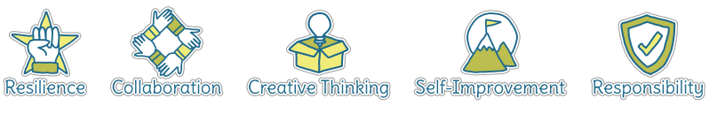
Five Ways to Wellbeing
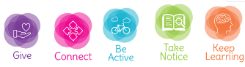

Vocabulary
Serve | Starting the game by hitting the ball
Court | The area where the ball is in play
Target | Place you are aiming for
Rally | Hit back and forwards between partners
Bounce | Where the ball hits the ground and comes back up
Fault | WHen the ball goes out of the court
Receiver | The person who the server is hitting to
Singles | 1-1 game
Doubles | 2-2 game
SIde lines | Markings the end of the court
Drop Shot | A shot that lands only just over the net

Image/diagram that helps me to articulate my knowledge/understanding | Investigate!
See Links ----> | -Build up skills to have your own wimbledon tournament (with cream and strawberries of course!)  -How many hits can you get between you and your partner?  -How many bounces can you do on your racket without dropping it?  -Can you land the ball in the target? (use different shape buckets)  https://www.sportaus.gov.au/__data/assets/pdf_file/0004/703966/Newcombe-Ball.pdf  https://www.sportaus.gov.au/__data/assets/pdf_file/0004/703948/Keep-up-the-ball.pdf (play with tennis rackets)  https://www.sportaus.gov.au/__data/assets/pdf_file/0005/703904/Continuous-tennis.pdf

