Goonhavern Primary School Physical Education
TOPIC: Invasion Games | YEAR: 3 | STRAND: Handball

What should I know already? | What will I know by the end of the unit?
From Year 1 and Year 2 Invasion games (specific to football):  - How to kick a ball with the side of your foot  - How to receive a ball with the side of your foot  - To pass by pushing the ball (note that there should not be a back swing).  - To pass whilst jogging with the ball.  - To receive the ball by cushioning it.  - To dribble in a straight line.  - To dribble and move in different directions.  - To tackle an opponent by taking the ball away from them.  - To develop strategies for attacking.  - To develop strategies for defending.  - To collaborate with teammates and communicate effectively.  - To show resilience and be able to win and lose in games. | To pass to a teammate by chest throw, overarm throw, underarm throw or bounce throw
 | To pass whilst jogging with the ball.
 | To receive the ball by cushioning it.
 | To look for space when passing or receiving
 | To move in different directions with the ball
 | To support team members by finding space and avoiding attackers
 | To develop strategies for attacking.
 | To develop strategies for defending.
 | To collaborate with teammates and communicate effectively.
 | To give the thrower space when attacking
 | To show resilience and be able to win and lose in games.
School Values
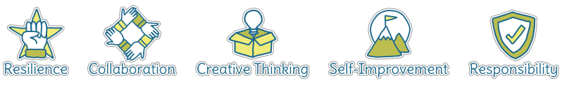

Five Ways to Wellbeing
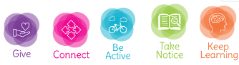

Vocabulary
Accuracy | How close you can get the ball/object to where you want it to go.
Receive | To catch or ‘get’ a ball or object that someone has passed to you.
Dribble | To control the ball whilst moving.
Tackle | To take the ball from an opponent.
Hand-eye coordination | The link between what you see and how your hands move (for example when catching a ball).
Attacking | Trying to score against the opposing
Defending | Trying to stop the opposing team from scoring
Tactic | A plan of action to help you achieve a goal.
Strategy | A plan of action to help you achieve a goal.
Intercept | To block the ball/object from reaching your opponent
Oppenenet | Someone on the opposite team as you.
Collaborate | Work together to achieve a shared goal.

Image/diagram that helps me to articulate my knowledge/understanding | Possible Games/Ideas
Rob the Nest  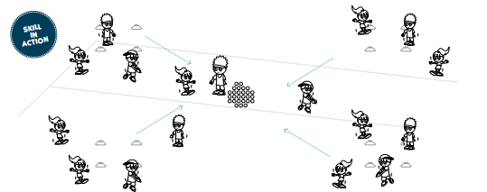  Protect the Nest  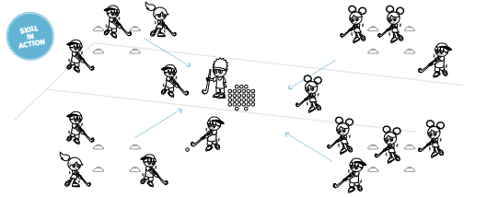 | Practise for dribbling:  Through the Gates and Rob the Nest  Lots of other activities:  Sport Australia

