Goonhavern Primary School
TOPIC: PE | YEAR: 3 | STRAND: Dance

What should I know already? | What will I know by the end of the unit?
Move accurately in time with music’s rhythm and pace  How to show expressive qualities in dance moves  Show emotions and energy levels through dance  How to smoothly transition from each move  Perform different movements simultaneously with opposite hands and feet  Remember and repeat short dance sequences  How to choose movements that suit the music and dance idea  Create short sequences with a beginning, middle and ending  Express how different dance performances you’ve watched make you feel and why | Use movements to tell a narrative
 | Combine and link an increasing number of movements
 | To explore different shapes and movements ( sway, whirl, spiral, fall, leap)
 | Compose a short dance phrase in small groups
 | Perform, appreciate and evaluate each other’s work.
 | To improvise freely to translate stimulus.
 | Perform dances with an awareness of rhythmic, dynamic and expressive qualities.
 | Keep a flow to a dance phase without hesitating
School Values
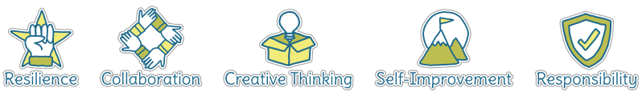
Five Ways to Wellbeing
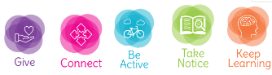

Vocabulary
Rhythm | Pattern and pace of music
pace | The speed
Energy levels | How much power
Emotion | feelings
Smooth | Without stopping/hestiating
Transition | Changing
Simultaneously | At the same time
Sequence | A collection of movements in a certain order
Control | Being able to manipulate
Pattern | The sequence where everything is the same
Narrative | A story
Improvise | Make up as you go along
Flow | Something that doesn’t stop

Image/diagram that helps me to articulate my knowledge/understanding | Investigate!
Create, perform and share short dances based on well known narratives that may be being learnt in class/links to PSHE and narratives that show emotions and feelings
Build up to a performance for parents, school
Explore different music and how it make syou feel
Explore emotions and how we can show these through dance
Talk about improvisation
What is flow? Look at images and videos of rivers flowing and professional dancers, what’s the same?

