Goonhavern Primary School
TOPIC: PE | YEAR: 4 | STRAND: Swimming

What should I know already? | What will I know by the end of the unit?
-Move in the pool (for example, jump, walk, hop, and spin, using swimming aids and/or support)  -Float and move with and without swimming aids  -Propel themselves in water using different swimming aids, arms and leg actions and basic strokes.  -Tread water for a sustained period of time  -Begin to learn some strokes (front crawl, backstroke, breaststroke)  -Know how to respond if themselves or someone else is in danger  -Know how to act safety around a pool | Swim on their front and back, using arm and leg actions together with smooth coordination
 | Control their breathing and are comfortable on the surface and underwater
 | Swim a length of a pool with some control using back crawl, front crawl and breaststroke
 | Know and use personal survival techniques, including floating, sculling and surface diving
 | Swim for more than 45 seconds and further than 50 metres
School Values
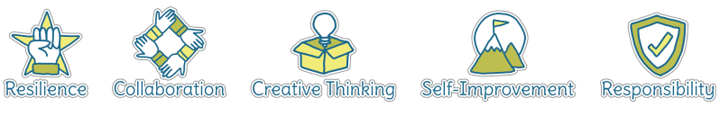
Five Ways to Wellbeing
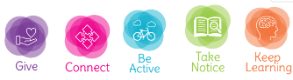

Vocabulary
Float | Stay above water
Swimming aids | Objects that help us float
Floats | Objects that help us float
Stroke | Arm movement in the water
Tread water | Kicking your legs to stay above water
Front crawl | a style of swimming in which the swimmer faces downwards and moves their arms alternately.
Backstroke | A style of swimming performed on your back
Breaststroke | A style of swimming where you arms move in and out from your breast
LIfeguard | A person who keeps us safe at a swimming pool
Coordination | Using different parts of the body smoothly at the same time
Sculling | Sculling is a back-and-forth motion with your hands, like you're drawing a figure eight

Image/diagram that helps me to articulate my knowledge/understanding | Investigate!
The 3 main different types of swim stroke
How far can you swim without stopping?
Breathing techniques best for swimming?
Explore the different survival techniques and why each one could be beneficial
More confident swimmers might trying diving to the bottom of the pool and practise holding their breath under water

