Goonhavern Primary School
TOPIC: PE | YEAR: 4 | STRAND: Rounders

What should I know already? | What will I know by the end of the unit?
-The difference between feilding and striking  -A bowler is someone who throws the ball to the batter  -How to throw a ball whilst moving  -How to track a ball and receive it  -How to return a ball with accuracy  -How to hit or strike the ball into spaces  -Develop throwing power and technique  -How to consider the best place to stand when feilding  -How to work in a team to keep opposing team’s points down  -How to create strategies in teams to keep opposing team’s points down  -How to work cooperatively and competitively with a partner | The rules for a game of rounders
 | Place the ball when batting through anticipation and adjustment of position.
 | Show control and timing in batting & bowling execution
 | Develop communication skills, teamwork through rounders game play
 | Develop creative thinking & outwitting opponents with the placement of the ball.
 | Develop under and over arm bowling technique
 | Develop batting technique incorporating power and placement.
 | How to place a team and adjust throughout a game for effectiveness when feilding
 | Make decisions about when to stop when running
 | Pass accurately and from a range of distances to team members
 | Analyse and make suggestions, which will improve individual play
School Values
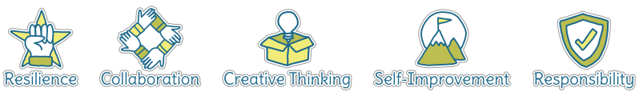
Five Ways to Wellbeing


Vocabulary
Feilding | To catch or stop the ball hit by the batter
Striking | To hit the ball
Bowler | Throwing the ball to the batter
Batter | Hitting the ball with a bat
Track | Follow
Strategy | A plan
Cooperatively | Working together
Competitively | Working against others to win
Team work | Working successfully in a team
Accuracy | Aiming for a certain place

Image/diagram that helps me to articulate my knowledge/understanding | Investigate!
https://www.sportplan.net/drills/Rounders/index.jsp (Good activity ideas on here)

Bat Tapping
https://www.sportaus.gov.au/__data/assets/pdf_file/0004/703885/Bat-tapping.pdf
Catching Challenge
https://www.sportaus.gov.au/__data/assets/pdf_file/0007/703897/catching-Challenge.pdf
Target Throw and Run
https://www.sportaus.gov.au/__data/assets/pdf_file/0011/704000/Target-throw-and-run.pdf

