Goonhavern Primary School Physical Education
TOPIC: Invasion Games | YEAR: 4 | STRAND: Netball

What should I know already? | What will I know by the end of the unit?
To pass to a teammate by chest throw, overarm throw, underarm throw or bounce throw  To pass whilst jogging with the ball.  To receive the ball by cushioning it.  To look for space when passing or receiving  To move in different directions with the ball  To support team members by finding space and avoiding attackers  To develop strategies for attacking.  To develop strategies for defending.  To collaborate with teammates and communicate effectively.  To give the thrower space when attacking  To show resilience and be able to win and lose in games. |  | Identify and complete the different passes used in netball- chest, bounce, shoulder pass
 |  | I can understand the rule of footwork, such as the pivot and the 3 second rule
 |  | Understand the rule of contact and the ball will go to the position if contact is made
 |  | Understand that marking helps to intercept the ball and dodging enables a player to get away from a marker
 |  | Complete the different types of dodge such as faint, sprint, and double dodge
 |  | State the difference between attacking skills and defending skills
 |  | Shoot accurately in a range of ways
 |  | Identify the different positions in netball and the different areas players can be in (Attacking, defending, positioning, shooting)
 |  | Practise a throw in from the sideline
 |  | Look at different strategic attack formations and defence formations
 |  | Play a game of netball incorporating all the rules
School Values
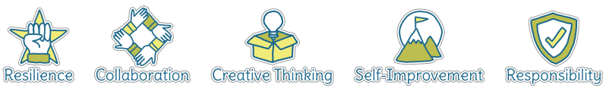
Five Ways to Wellbeing
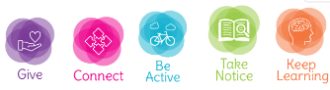

Vocabulary
Accuracy | How close you can get the ball/object to where you want it to go.
Receive | To catch or ‘get’ a ball or object that someone has passed to you.
Pivot | Rotate without stepping
Tackle | To take the ball from an opponent.
Dodge | To avoid
Attacking | Trying to score against the opposing
Defending | Trying to stop the opposing team from scoring
Tactic | A plan of action to help you achieve a goal.
Strategy | A plan of action to help you achieve a goal.
Intercept | To block the ball/object from reaching your opponent
Formations | Positions you can stand in as a team
Collaborate | Work together to achieve a shared goal.

Image/diagram that helps me to articulate my knowledge/understanding | Possible Games/Ideas
Rob the Nest  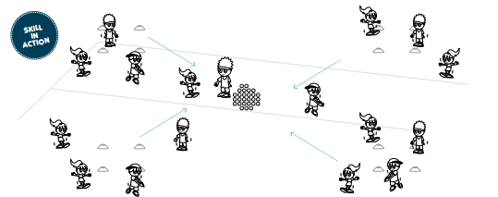  Protect the Nest  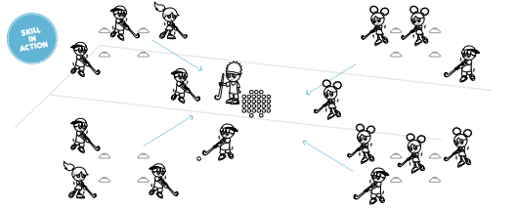 | Keep the Ball  https://www.sportaus.gov.au/__data/assets/pdf_file/0003/703947/Keep-the-ball.pdf  Pairs Passing  https://www.sportaus.gov.au/__data/assets/pdf_file/0003/703974/Pairs-passing.pdf  Pass and Run  https://www.sportaus.gov.au/__data/assets/pdf_file/0005/703976/Pass-and-Run.pdf

