Goonhavern Primary School- SUBJECT
TOPIC: PE | YEAR: 4 | STRAND: Dance

What should I know already? | What will I know by the end of the unit?
Use movements to tell a narrative  Combine and link an increasing number of movements  To explore different shapes and movements ( sway, whirl, spiral, fall, leap)  Compose a short dance phrase in small groups  Perform, appreciate and evaluate each other’s work.  To improvise freely to translate stimulus.  Perform dances with an awareness of rhythmic, dynamic and expressive qualities.  Keep a flow to a dance phase without hesitating | Understand and explain different genres of dance (e.g. street dance, jazz, ballet etc) and be able to name moves specific to these genres
 | How to combine skills learnt in gymnastics with dance
 | Create longer narratives and explain why certain movements have been chosen to reflect mood and emotion
 | Know how to create short dances phases in partners and groups incorporating symmetry
 | Comment on dynamics, flow and rhythm of other people’s performances and give suggestions for improvements
 | Adapt and refine the way they use weight, space and rhythm in their dances to express themselves in the style of dance they use.
School Values
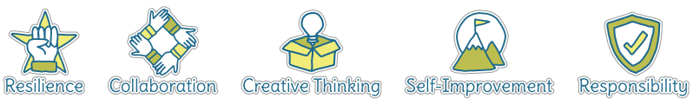
Five Ways to Wellbeing
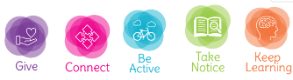

Vocabulary
Rhythm | Pattern and pace of music
pace | The speed
Energy levels | How much power
Emotion | feelings
Smooth | Without stopping/hestiating
Transition | Changing
Simultaneously | At the same time
Sequence | A collection of movements in a certain order
Control | Being able to manipulate
Pattern | The sequence where everything is the same
Narrative | A story
Improvise | Make up as you go along
Flow | Something that doesn’t stop

Image/diagram that helps me to articulate my knowledge/understanding | Investigate!
Create, perform and share short dances based on well known narratives that may be being learnt in class/links to PSHE and narratives that show emotions and feelings
Build up to a performance for parents, school
Explore different music and how it make syou feel
Explore emotions and how we can show these through dance
Talk about improvisation
What is flow? Look at images and videos of rivers flowing and professional dancers, what’s the same?

