Goonhavern Primary School
TOPIC: PE | YEAR: 4 | STRAND: Athletics

What should I know already? | What will I know by the end of the unit?
-Focus on their arm and leg action to improve their sprinting technique.  -Begin to combine running with jumping over hurdles.  -Focus on trail leg and lead leg action when running over hurdles.  -Understand the importance of adjusting running pace to suit the distance being run.  -Use one and two feet to take off and to land with.  -Develop an effective take-off for the standing long jump.  -Develop an effective flight phase for the standing long jump.  -Land safely and with control  -Throw with greater control and accuracy.  -Show increasing control in their overarm throw.  -Perform a push throw. Continue to develop techniques to throw for increased distance. | How to confidently demonstrate an improved technique for sprinting.
 | How to carry out an effective sprint finish.
 | To perform a relay, focusing on the baton changeover technique.
 | How to speed up and slow down smoothly
 | How to learn how to combine a hop, step and jump to perform the standing triple jump.
 | How to land safely and with control.
 | How to begin to measure the distance jumped.
 | How to perform a pull throw.
 | How to measure the distance of their throws.
 | Continue to develop techniques to throw for increased distance.
School Values
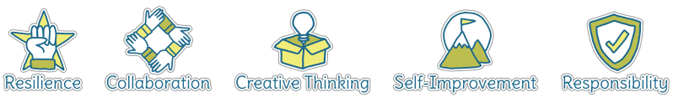
Five Ways to Wellbeing


Vocabulary
Sprint | Faster speed than a run
Hurdles | Barriers to jump over
Trail leg | Leg that goes last
Lead leg | Leg that goes first
Pace | The speed you are moving
Take off | How you begin a jump
Flight phase | What happens whilst you are in the air
Push throw | Where the ball is pushed away from your chest
Triple Jump | A jump that combines a hop, step and jump
Pull Throw | When arm is pulled back to maximise strength in the throw

Image/diagram that helps me to articulate my knowledge/understanding | Investigate!
Practise activities leading up to Sport’s Day

Throwing Games:
https://www.sportaus.gov.au/__data/assets/pdf_file/0006/703941/How-high.pdf
https://www.sportaus.gov.au/__data/assets/pdf_file/0011/703955/long-throw.pdf
Running/Relay
https://www.sportaus.gov.au/__data/assets/pdf_file/0003/703929/Get-the-bean-bag.pdf

