Goonhavern Primary School
TOPIC: PE | YEAR: 5 | STRAND: Badminton

What should I know already? | What will I know by the end of the unit?
Transferable skills from tennis:  -To throw a ball to a partner correctly and with accurately  -To move around with the ball using your hands keeping it under control  -To use a tennis racket to move a tennis ball around the playground  -To perform a variety of skills using a tennis racket  -To understand the action we use when playing a tennis shot  -To be able to push the ball with a tennis racket along the floor  -To serve the ball towards a partner  -To serve the ball towards a target  -To keep the score of a short game  -To be able to perform a rally with a partner  -To be able to hit the ball over a net | How to demonstrate backhand “thumb” grip and forehand “v” grip;
 | How to demonstrate a relaxed reach when striking the shuttle (or soft ball / balloon)
 | How to use chasse steps over short distances
 | Be able to lunge with good range and the front foot pointing to the impact point of the shuttle;
 | Be able to consistently strike net shots using a pushing action and appropriate grip.
 | Consistently (7/10) strike net shots using a pushing action and basic grips;
 | Explain and demonstrate the use of the split step and lunge
 | Organise and participate in a variety of forecourt net games
 | How to demonstrate a backhand short serve
 | Be able to rally in the front court
 | Be able to demonstrate front court backhand lift.
School Values
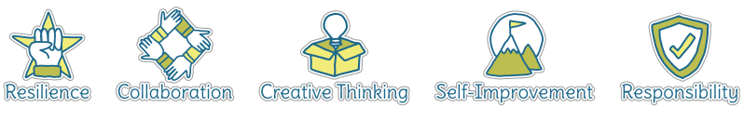
Five Ways to Wellbeing
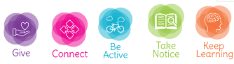

Vocabulary
Rally | Hit back and forwards between partners
Shuttlecock | object you hit with your racket
Fault | WHen the ball goes out of the court
Receiver | The person who the server is hitting to
Singles | 1-1 game
Doubles | 2-2 game
SIde lines | Markings the end of the court
Drop Shot | A shot that lands only just over the net
Serve | Starting the game by hitting the ball
Court | The area where the ball is in play
Target | Place you are aiming for
Chasse Step | one foot extended forward, the back foot then “chases” and meets up with the front for a quick moment before the front foot shoots forward again, all while traveling forward
Grip | How the racket is being held
Backhand | Back of your hand is facing the net
Lunge | One leg bent forwards in front of your body

Image/diagram that helps me to articulate my knowledge/understanding | Investigate!
See Links ----> | http://www.northumberlandbadminton.org/wp-content/uploads/Lesson-Plans-10-Starter-Lessons1.pdf (good lesson ideas on here)  Adapt some of these with badminton rackets and shuttlecocks  https://www.sportaus.gov.au/__data/assets/pdf_file/0005/703949/King-Queen-of-the-court.pdf  https://www.sportaus.gov.au/__data/assets/pdf_file/0004/703966/Newcombe-Ball.pdf  https://www.sportaus.gov.au/__data/assets/pdf_file/0005/703904/Continuous-tennis.pdf

