Goonhavern Primary School
TOPIC: PE | YEAR: 5 | STRAND: Rugby

What should I know already? | What will I know by the end of the unit?
Transferable skills from previous years:  - How to ‘catch’/receive a ball that has been rolled.  - How to throw a ball with two hands (chest/shoulder pass)  - How to prepare to catch a ball  - How to to catch a ball (cushioning the ball with my hands)  - One or two tactics for attacking and defending  - To develop strategies for attacking.  - To develop strategies for defending.  - To collaborate with teammates and communicate effectively.  - To show resilience and be able to win and lose in games. | How to evade and tag opponents.
 | How to safely run at speed and change direction
 | How to effectively use the space and aim for the gaps
 | How to evade opponents while keeping control of the rugby ball.
 | How to run with the ball while holding it in the correct position
 | How to pass the ball accurately and receive the ball safely
 | How to pass the ball accurately and receive the ball safely whilst on the move
 | Remembering to open up hands to give the passer a target
 | Communicate effectively with team mates
 | That a ball must be passed backwards during a rugby match
 | Know the basic rules of a rugby match
School Values
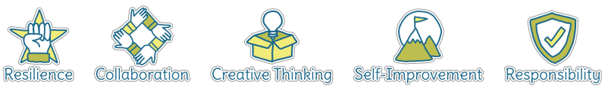
Five Ways to Wellbeing


Vocabulary
Evade | Attempt to avoid opposing team
Tag | Tapping opponent in a match
Try | Scoring a point
Defending | Stop opponents scoring
Attacking | Challenging opposing team
Knock on | When a ball goes forwards by accident
Forwards pass | When a ball is thrown forwards rather than back
Tackle | An attempt to get ball from other team

Image/diagram that helps me to articulate my knowledge/understanding | Investigate!
Rugby sessions with Pirates

Change to use a rugby ball:
https://www.sportaus.gov.au/__data/assets/pdf_file/0010/703972/On-court-off-court-rapid-pass.pdf
https://www.sportaus.gov.au/__data/assets/pdf_file/0005/703976/Pass-and-Run.pdf

