Goonhavern Primary School
TOPIC: PE | YEAR: 5 | STRAND: Basketball

What should I know already? | What will I know by the end of the unit?
Transferable skills from year 4 (netball)  Identify and complete the different passes used in netball- chest, bounce, shoulder pass  I can understand the rule of footwork, such as the pivot and the 3 second rule  Understand the rule of contact and the ball will go to the position if contact is made  Understand that marking helps to intercept the ball and dodging enables a player to get away from a marker  Complete the different types of dodge such as faint, sprint, and double dodge  State the difference between attacking skills and defending skills  Shoot accurately in a range of ways  Identify the different positions in netball and the different areas players can be in (Attacking, defending, positioning, shooting)  Practise a throw in from the sideline  Look at different strategic attack formations and defence formations  Play a game of netball incorporating all the rules | How to control the ball when dribbling using shoulder and wrist movements
 | How to keep the ball close to enable a turn to take place
 | How to use hands alternatively not together when dribbling for effectiveness
 | Chest pass – pass the ball with two hands from the chest, pushing the ball away from their body.
 | Bounce pass – pass the ball with one bounce between the passer and the receiver. Judge the distance between the two and aim accordingly.
 | Shoulder pass – for longer distances. Using one hand overhead.
 | Make a ‘W’ shape with hands when receiving to make a big target for the person passing to aim at.
 | Pass and move working as a team.
 | How to work together by creating space for teammates to receive the ball from them.
 | You need to aim for the square above the hoop on the backboard when shooting
 | You can generate power by throwing upwards from about chest height.
 | Use appropriate shooting technique when in the correct areas to shoot
School Values
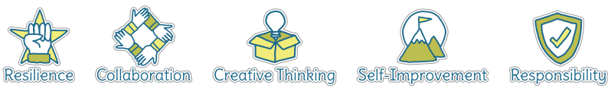
Five WAys to Wellbeing
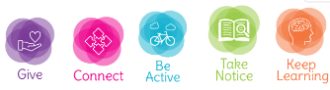

Vocabulary
Accuracy | How close you can get the ball/object to where you want it to go.
Receive | To catch or ‘get’ a ball or object that someone has passed to you.
Pivot | Rotate without stepping
Tackle | To take the ball from an opponent.
Dodge | To avoid
Attacking | Trying to score against the opposing
Defending | Trying to stop the opposing team from scoring
Tactic | A plan of action to help you achieve a goal.
Strategy | A plan of action to help you achieve a goal.
Intercept | To block the ball/object from reaching your opponent
Formations | Positions you can stand in as a team
Collaborate | Work together to achieve a shared goal.

Image/diagram that helps me to articulate my knowledge/understanding | Investigate!
See links----> | https://www.sportaus.gov.au/__data/assets/pdf_file/0010/703909/Defend-the-zone.pdf  https://www.sportaus.gov.au/__data/assets/pdf_file/0007/703879/5-point-player.pdf  https://www.sportaus.gov.au/__data/assets/pdf_file/0020/703910/Dribblers-and-robbers.pdf  https://www.sportaus.gov.au/__data/assets/pdf_file/0009/703971/Numbers.pdf

