Goonhavern Primary School
TOPIC: PE | YEAR: 5 | STRAND: Gymnastics

What should I know already? | What will I know by the end of the unit?
-To confidently know and perform floor shapes such as crab, bridge, v-sit, shoulder stand, planche and frog balance  -To confidently know and perform a variety of rolls  -How to bring explosive moves into my floorwork through jumps and leaps  -Know how I can increase my flexibility gradually over time uses different stretches  -How to effectively perform in time with a partner and a group  -Know muscles groups needed to support the core of their body  -How to take weight on small and large body parts, for example hand and shoulder  -To use skills above and create sequences both on the floor and the apparatus | How to create longer and more complex sequences and adapt performances
 | How to take the lead in a group when preparing a sequence
 | How to develop symmetry individually, as a pair and in a small group using body parts
 | Compare performances and judge strengths and areas for improvement
 | Select a component for improvement. For example—timing or flow
 | Take responsibility in own warm up including remembering and repeating a variety of stretches
 | Use information given by others to improve performance
School Values
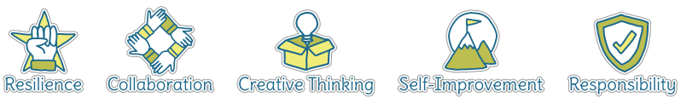
Five Ways to Wellbeing
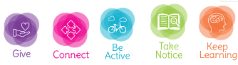

Vocabulary
Floor Shapes | Shapes you create on the mat
Crab | Face up arching back up
Bridge | Face down arching back up
Teddy Bear Roll | Roll to the side
Forward Roll | Head first roll
V-sit | Straight legs and back creating a V shape
Shoulder Stand | Legs shoulder width apart
Planche | The body is held parallel to the ground, while being supported above the floor by straight arms.
Frog Balance | Crouching holding weight with only hands
Traversing | Going backwards
Vault | Gymnastic apparatus
Mount | Climb onto
Dismount | Climb off
Symmetry | A shape that can be split down the middle is a mirror image on both sides

Image/diagram that helps me to articulate my knowledge/understanding | Investigate!
Create short sequences as a class, in groups and pairs
Give opportunity to watch others, copy routines and comment on techniques whilst giving peer feedback
Build up from floor shapes to creating these on apparatus building up confidence to get higher
Games to play:
https://www.sportaus.gov.au/__data/assets/pdf_file/0012/704001/Team-alphabet.pdf
https://www.sportaus.gov.au/__data/assets/pdf_file/0006/703986/Shapes-in-space.pdf
https://www.sportaus.gov.au/__data/assets/pdf_file/0006/703986/Shapes-in-space.pdf

