Goonhavern Primary School
TOPIC: PE | YEAR: 6 | STRAND: Swimming

What should I know already? | What will I know by the end of the unit?
-Move in the pool (for example, jump, walk, hop, and spin, using swimming aids and/or support)  -Float and move with and without swimming aids  -Propel themselves in water using different swimming aids, arms and leg actions and basic strokes.  -Tread water for a sustained period of time  -Begin to learn some strokes (front crawl, backstroke, breaststroke)  -Know how to respond if themselves or someone else is in danger  -Know how to act safety around a pool  Swim on their front and back, using arm and leg actions together with smooth coordination  -Control their breathing and are comfortable on the surface and underwater  -Swim a length of a pool with some control using back crawl, front crawl and breaststroke  -Know and use personal survival techniques, including floating, sculling and surface diving  -Swim for more than 45 seconds and further than 50 metres | How to perform a flat stationary scull on the back and perform a feet first sculling action for 5 metres in a flat position on the back
 | Perform three different shaped jumps into deep water.
 | Swim a further distance of pool with some control using back crawl, front crawl and breaststroke
 | Attempt to swim above strokes with some speed whilst maintaining correct form
 | How to perform a seated or standing dive
 | Swim through obstacles and complete an obstacle course whilst keeping feet off the ground
 | How to begin to push and glide and swim 10 metres butterfly
 | Perform a forward somersault
 | Perform a handstand and hold for a minimum of three seconds
 | How to perform a pool rescue and basic first aid at a poolside
School Values
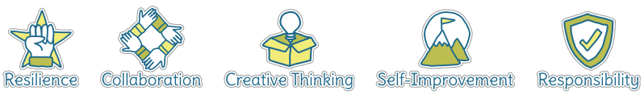
Five Ways to Wellbeing
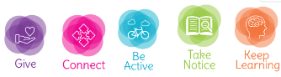

Vocabulary
Float | Stay above water
Swimming aids | Objects that help us float
Floats | Objects that help us float
Stroke | Arm movement in the water
Tread water | Kicking your legs to stay above water
Front crawl | a style of swimming in which the swimmer faces downwards and moves their arms alternately.
Backstroke | A style of swimming performed on your back
Breaststroke | A style of swimming where you arms move in and out from your breast
LIfeguard | A person who keeps us safe at a swimming pool
Coordination | Using different parts of the body smoothly at the same time
Sculling | Sculling is a back-and-forth motion with your hands, like you're drawing a figure eight

Image/diagram that helps me to articulate my knowledge/understanding | Investigate!
The 3 main different types of swim stroke and introduce to butterfly for more confident swimmers
How far can you swim without stopping?
Breathing techniques best for swimming?
Explore the different survival techniques and why each one could be beneficial
More confident swimmers might trying diving to the bottom of the pool and practise holding their breath under water
Use obstacles to swim through
How can you use gymnastics skills in the pool?
Incorporate life saving skills for confident swimmers

