Goonhavern Primary School
TOPIC: PE | YEAR: 6 | STRAND: Rugby

What should I know already? | What will I know by the end of the unit?
-How to evade and tag opponents.  -How to safely run at speed and change direction  -How to effectively use the space and aim for the gaps  -How to evade opponents while keeping control of the rugby ball.  -How to run with the ball while holding it in the correct position  -How to pass the ball accurately and receive the ball safely  -How to pass the ball accurately and receive the ball safely whilst on the move  -Remembering to open up hands to give the passer a target  -Communicate effectively with team mates  -That a ball must be passed backwards during a rugby match  -Know the basic rules of a rugby match | How to communicate with my team and move into space to keep possession and score
 | How to pass and receive the ball at speed and under pressure
 | Tag opponents individually and when working as a unit
 | How to use the rules of game to work consistently and honestly
 | Know the different positions and rugby and how each position contributes to the match
 | How to work collaboratively to create tactics with my team and how to evaluate these
 | To know I need to include all team members when creating tactics to score
 | How to smoothly pass a ball backwards and with accuracy
 | How to dodge and lose a defender
 | Know the right time to pass a ball
 | To know the offside rules in rugby and when the ball needs to be given to the opposing team
School Values
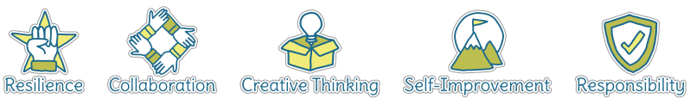
Five Ways to Wellbeing


Vocabulary
Evade | Attempt to avoid opposing team
Tag | Tapping opponent in a match
Try | Scoring a point
Defending | Stop opponents scoring
Attacking | Challenging opposing team
Knock on | When a ball goes forwards by accident
Forwards pass | When a ball is thrown forwards rather than back
Tackle | An attempt to get ball from other team

Image/diagram that helps me to articulate my knowledge/understanding | Investigate!
 | Rugby with Pirates rugby coaches

