Goonhavern Primary School
TOPIC: PE | YEAR: 6 | STRAND: Football

What should I know already? | What will I know by the end of the unit?
Transferable skills from rugby:  -How to communicate with my team and move into space to keep possession and score  -How to pass and receive the ball at speed and under pressure  -Tag opponents individually and when working as a unit  -How to use the rules of game to work consistently and honestly  -Know the different positions and rugby and how each position contributes to the match  -How to work collaboratively to create tactics with my team and how to evaluate these  -To know I need to include all team members when creating tactics to score  -How to smoothly pass a ball backwards and with accuracy  -How to dodge and lose a defender  -Know the right time to pass a ball  -To know the offside rules in rugby and when the ball needs to be given to the opposing team | How to show basic control skills including sending and receiving the ball.
 | How to send the ball with some accuracy to maintain possession and build attacking play
 | How to implement the basic rules of football
 | Some defensive skills and where to position yourself when in defence throughout a game
 | How to dribble in different directions using different parts of their feet
 | How to pass for distance and know when the right time is to do this in a game
 | How to play effectively in a variety of positions and formations on the pitch
 | How to suggest, plan and lead simple drills for given skills
 | How to play in goal position and explain what skills are required
 | How to tackle an opponent to gain possession
 | To know the offside rules for the match
School Values
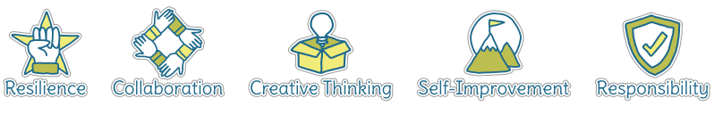
Five Ways to Wellbeing


Vocabulary
Offside | When the ball is no longer in play
Dribble | Moving with the ball whilst maintaining control
Pass | Kicking the ball to a team member
Drills | Exercises that develop skills for the game
Possession | Keeping hold of the ball
Defence | Stopping the opposing team scoring
Attack | Trying to gain possession from other team
Goalie | Position in the goal
Tackle | Using feet to get possession of the ball
Back pass | When the ball is passed back towards their own goal

Image/diagram that helps me to articulate my knowledge/understanding | Investigate!
Develop skills to play short matches both in small teams (5 a side) and larger teams.
Explore variations of football e.g. crab football and blind football, which skills are transferable?
Focus on importance of teamwork
Adapt to football
https://www.sportaus.gov.au/__data/assets/pdf_file/0004/703912/End-to-end.pdf
https://www.sportaus.gov.au/__data/assets/pdf_file/0007/703879/5-point-player.pdf

