Goonhavern Primary School
TOPIC: PE | YEAR: 6 | STRAND: Athletics

What should I know already? | What will I know by the end of the unit?
-How to accelerate from a variety of starting positions and select their preferred position.  -How to identify their reaction times when performing a sprint start.  -To continue to practise and refine their technique for sprinting, focusing on an effective sprint start.  -How to select the most suitable pace for the distance and their fitness level in order to maintain a sustained run.  -How to identify and demonstrate stamina, explaining its importance for runners.  -Improve techniques for jumping for distance.  -How to perform an effective standing long jump and perform the standing triple jump with increased confidence.  -Develop an effective technique for the standing vertical jump (jumping for height) including take-off and flight.  -Perform a fling throw.  -Throw a variety of implements using a range of throwing techniques. | Recap, practise and refine an effective sprinting technique, including reaction time.
 | Build up speed quickly for a sprint finish.
 | Run over hurdles with fluency, focusing on the lead leg technique and a consistent stride pattern.
 | Accelerate to pass other competitors.
 | Work as a team to competitively perform a relay.
 | Confidently and independently select the most appropriate pace for different distances and different parts of the run.
 | Demonstrate endurance and stamina over longer distances in order to maintain a sustained run.
 | Develop the technique for the standing vertical jump.
 | Maintain control at each of the different stages of the triple jump.
 | Develop and improve their techniques for jumping for height and distance and support others in improving their performance.
 | Perform a heave throw.
 | Measure and record the distance of their throws.
 | Continue to develop techniques to throw for increased distance and support others in improving their personal best.
School Values
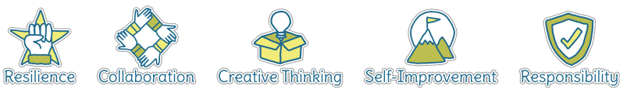

Five Ways to Wellbeing


Vocabulary
Sprint | Faster speed than a run
Hurdles | Barriers to jump over
Trail leg | Leg that goes last
Lead leg | Leg that goes first
Pace | The speed you are moving
Take off | How you begin a jump
Flight phase | What happens whilst you are in the air
Push throw | Where the ball is pushed away from your chest
Triple Jump | A jump that combines a hop, step and jump
Pull Throw | When arm is pulled back to maximise strength in the throw
Vertical Jump | Jumping as high as you can
Heave Throw | Ability to throw heavier objects over a distance

Image/diagram that helps me to articulate my knowledge/understanding | Investigate!
Practise activities leading up to Sport’s Day

Throwing Games:
https://www.sportaus.gov.au/__data/assets/pdf_file/0006/703941/How-high.pdf
https://www.sportaus.gov.au/__data/assets/pdf_file/0011/703955/long-throw.pdf
Running/Relay
https://www.sportaus.gov.au/__data/assets/pdf_file/0003/703929/Get-the-bean-bag.pdf

