Goonhavern Primary School- SUBJECT
TOPIC: PE | YEAR: 1 | STRAND: Net/Wall Games (multi-skills)

What should I know already? | What will I know by the end of the unit?
From EYFS:  - Experiments with different ways of moving.  - Jumps off an object and lands appropriately.  - Negotiates space successfully when playing racing and chasing games with other children, adjusting speed or changing direction to avoid obstacles.  - Travels with confidence and skill around, under, over and through balancing and climbing equipment.  - Shows increasing control over an object in pushing, patting, throwing, catching or kicking it.  - Early Learning Goal Children show good control and co-ordination in large and small movements. They move confidently in a range of ways, safely negotiating space | How to throw a ball to hit a target
 | How to defend a ball from hitting a target
 | How to throw at a still and moving target
 | How to pass a ball over different height nets
 | How to catch a ball that’s rebounded
 | How to bounce a ball accurately
 | How to hold a racket
 | How to balance a ball on a racket
 | How to bounce and catch a ball to yourself with hands and with a racket
 | How to hit a ball with a racket
School Values
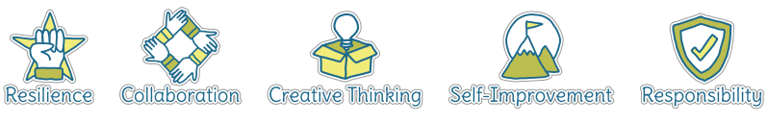
Five Ways to Wellbeing
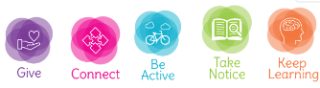

Vocabulary
Racket | Equipment used in net and wall games
Defend | Stopping an attack/scoring points
Target | Something to aim for
Rebound | When it bounces back
Control | Being able to manipulate with accuracy
Position | Where you stand
Power | How hard you hit something
Court | The area where the game is being played
Opponent | Person you are playing against

Image/diagram that helps me to articulate my knowledge/understanding | Investigate!
See Links ---> | -Experiment using different rackets (badminton and tennis)  -Experiment using different size balls (tennis balls, dodgeballs, volley balls)  -Experiment using different height nets  -Playing against a wall  -Playing against an opponent.  -Build up to a mini tennis or volleyball tournament  Rebound Ball:  https://www.sportaus.gov.au/__data/assets/pdf_file/0003/703983/Rebound-ball.pdf  Keep up the Ball  https://www.sportaus.gov.au/__data/assets/pdf_file/0004/703948/Keep-up-the-ball.pdf  No Go  https://www.sportaus.gov.au/__data/assets/pdf_file/0006/703968/No-go.pdf  2 square bounce  https://www.sportaus.gov.au/__data/assets/pdf_file/0004/703876/2-Square-Bounce.pdf

