Goonhavern Primary School- RE
TOPIC: RE | YEAR: 1 | STRAND: Judaism

What should I know already? | What will I know by the end of the unit?
- What is right and wrong.  - That we are all different and have different beliefs.  - Understand how to respect other people’s beliefs. | • Words of the Shema as a Jewish prayer  • Simple stories used in Jewish celebrations (e.g. Chanukah)  • How stories are used in celebration  • Know how Jewish people celebrate special times (e.g. Shabbat, Sukkot, Chanukah)  • Make links between Jewish ideas of God found in the stories and how people live  • Give an example of how some Jewish people might remember God in different ways (e.g. mezuzah, on Shabbat)
School Values
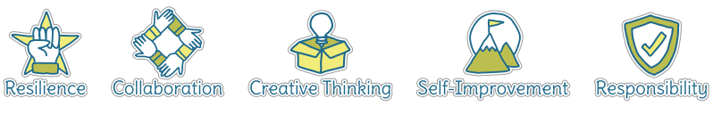
Five Ways to Wellbeing
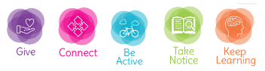

Vocabulary
Shema | An important Jewish prayer
Judaism | A major world religion that believes in one God
Jew | A person who follows Judaism
Chanukah | An eight day Jewish festival remembering the fight against the Greeks
Shabbat | Jewish day of rest
Sukkot | A Jewish festival held in the Autumn to remember sheltering the Iseralites
Mezuzah | A piece of paper with holy scripts

Image/diagram that helps me to articulate my knowledge/understanding | Investigate!
What important items do you have in your home? Not in terms of money but in terms of being meaningful. Why are they important?
Find out what special objects Jewish people might have in their home
• Look at a mezuzah, how it is used? Find out why many Jews have this in their home. What words would you have displayed in your home and why?
• What do many Jewish people do in the home on Shabbat?
Consider the importance and value of celebration and remembrance in your own lives. Experience celebrating in the classroom, with music, food or fun, and talk about how special times can make people happy and thoughtful. Make connections with the ways in which Jews celebrate, talk and remember, and talk about why this is so important to Jewish people, and to others.

