Goonhavern Primary School- RE
TOPIC: RE | YEAR: 1 | STRAND: Christianity

What should I know already? | What will I know by the end of the unit?
- What is right and wrong.  - That we are all different and have different beliefs.  - Understand how to respect other people’s beliefs. | That Christians describe God as omnipotent (all powerful) omnipresent (everywhere) omniscient (all knowing) omnibenevolent (all loving)
 | The Bible is a special book and can tell us what God is like
 | A parable is a story from the Bible that tells us what God is like
 | That Christians believed God created the world, as read in the creation story in the Bible
 | Christmas is an important event for Christians because it is when Jesus was born who Christians believe is God’s son.
 | The story of the Nativity tells us how Jesus was born
School Values
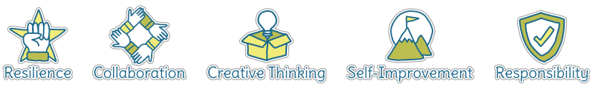
Five Ways to Wellbeing
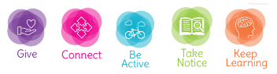

Vocabulary
Parable | A story from the bible
Forgiveness | Accept an apology
Incarnation | God made flesh (like in the nativity story)
Creator | The God who cares for the world.
Nativity | The events that surround Jesus’ birth.
Omnipotent | All powerful
omnipresent | everywhere
Ombenevolent | All loving
Bible | A holy book
Gospel | Stories about Jesus’s life

Image/diagram that helps me to articulate my knowledge/understanding | Investigate!
-What do Christians believe God is like? (use a parable from the bible to help, e.g. the lost son teaches about a forgiving and loving God) How do these link to our lives? E.g. what happens if you do something wrong in school?

-Who do Christians say made the world? Read Genesis. Why might Christians be thankful? Talk about creators of different objects. What would they be like? Why is our world amazing? What questions would you ask the creator?

-Why does Christmas matter to Christians? Tell the story of the nativity, explain that it’s from the gospel. What’s advent? What traditions do Christians have? How is Christmas different and the same for Christians and non Christians?

*Invite a vicar/priest in during this unit to speak to the children.

Links to well-being: connect, take notice, give
Links to school values: self improvement collaboration

