Goonhavern Primary School- RE
TOPIC: RE | YEAR: 2 | STRAND: Islam

What should I know already? | What will I know by the end of the unit?
- What is right and wrong.  - That we are all different and have different beliefs.  - Understand how to respect other people’s beliefs.  - Names of Jewish festivals and holy days.  - That Christians and Jews believe in one God  - Both Christians and Jews read the bible  - Religions have special objects and places | Know the words of the Shahadah and that it is very important for Muslims  • Musilims believe in one God (Allah) found in the Shahadah are the 99 names of Allah, and give a simple description of what some of them meanGod chose his prophet Muhammad to teach people about Islam  • Give examples of how stories about the Prophet show what Muslims believe about Muhammad  • Give examples of how Muslims use the Shahadah to show what matters to them  • Muslims use stories about the Prophet to guide their beliefs and actions  • Give examples of how Muslims put their beliefs about prayer into action  :
School Values
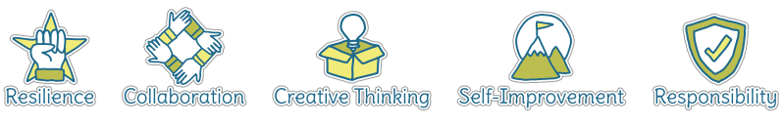
Five Ways to Wellbeing
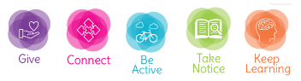

Vocabulary
Allah | God
Islam | A religion who believes in one God
Muslim | A person who follows Islam
Shahadah | Muslim profession of faith
Muhammad | The prophet chosen by Allah
Qur’an | The holy book for Muslims
Prophet | A special person chosen to spread God’s word
Tawid | Means one God
Iman | Means belief

Image/diagram that helps me to articulate my knowledge/understanding | Investigate!
• Find out about Muslim’s belief in Allah as the one true God
• Find out about the Shahadah, and how this is the most important belief for Muslims.
Revisit the Shahadah – it says Muhammad is God’s messenger. Now find out about the message given to Muhammad by exploring the story of the first revelation he received of the Holy Qur’an on the ‘Night of Power
’. Find out about how, where, when and why Muslims read the Qur’an, and work out why Muslims treat it as they do
• Introduce the idea of the Five Pillars as examples of ‘ibadah’, or ‘worship’. Reciting the Shahadah is one Pillar. Another is prayer, ‘salah’. Look at how Muslims try to pray regularly (five times a day). Find out what they do and say, and why this is so important to Muslims. What difference does it make to how they live every day?

