Goonhavern Primary School- RE
TOPIC: RE | YEAR: 2 | STRAND: Christianity

What should I know already? | What will I know by the end of the unit?
- What is right and wrong.  - That we are all different and have different beliefs.  - Understand how to respect other people’s beliefs.  - How Christians describe God as loving and forgiving  - Why Christians celebrate Christmas  - That Christians believe God created the world | Gospels are stories about Jesus’s life
 | Jesus chose 12 people to be his disciples who were his special friends
 | The Gospels teach about friendship, peace and forgiveness
 | A church is a special building for Christian worship
School Values
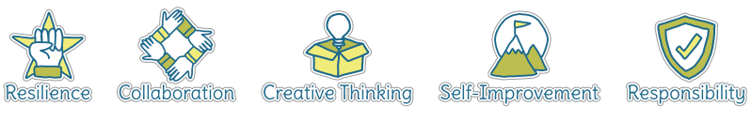
Five Ways to Wellbeing


Vocabulary
Worship | Expression of reverence and adoration.
Gospel | Means Good News are stories about Jesus’s life
Prayer | Communicating with God
Dicycles | Jesus’s special friends
Holy Week | The lead up to Easter
Easter | An event that surrounds Jesus’ death and the day he rose from the dead
Good FRiday | The day Jesus died
Resurrection | Coming back from the dead
Salvation | Rescuing people
Priest/Vicar | An important leader in a Christian community.

Image/diagram that helps me to articulate my knowledge/understanding | Investigate!
-What is the Good news Christians say Jesus brings? Learn about Jesus’s disciples and who he chose. If you could choose 12 people to change the world, who would you choose and why? Why did Jesus choose his friends? How do Christians share the ‘good news’ now? (e.g. food banks) Investigate a church building, how does the building help Christians remember Jesus’s Good News? Where can Christians find friendship, peace and forgiveness in this place?

-Why does Easter matter to Christians? Introduce the story of holy week, reflect on each part of the story, how does it make you feel? How did Jesus feel or his followers? Use drama/diary entries. How is it celebrated inside the church? How does the story change from sadness to happiness? Talk about heaven.

-Why are some places sacred? Visit to a church to explore how it is used

-How should we care for others and the world, and why does it matter? Read stories from the bible that teach this. Learn about people who have been inspired to help other because of ethical beliefs (e.g mother Theresa, charities (perhaps invite a charity speaker in?) What is our role in God’s creation? Link to helping the world and others

School Values: self improvement
5 ways to well being: give, take notice

