Goonhavern Primary School- SPANISH
TOPIC: Tell Me About... | YEAR: 3 T3 | STRAND: Spanish

What should I know already? | What will I know by the end of the unit?
- To identify two ‘d’ sounds in Spanish.  - Be able to say in Spanish what we are good at.  - To know the months of the year in Spanish.  - To be able to follow instructions in Spanish.  - To know the Spanish words for body parts.  - To know the parts of the face in Spanish.  - To know the parts of the body in Spanish.  - To write descriptive phrases in Spanish. | The key words for animals in Spanish.
 | How to read and use verbs in Spanish.
 | How to answer a question in a full sentence.
 | How to speak clearly in Spanish.
 | How to remember key phrases and sentences.
 | How to remember keywords from a story.
 | How to ask and answer questions in Spanish.
 | How to write simple sentences.
School Values
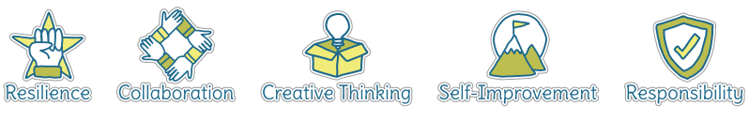
Five Ways to Wellbeing
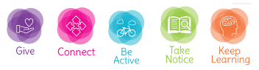

Vocabulary
Animals |  | Questions and Answers
Los animales | animals | ¿Cuándo? | When?
El perro | dog | ¿Dónde? | Where?
El gato | cat | ¿Adónde? | Where to?
El conejo | rabbit | ¿Cuántos? | How many?
El cerdo | pig | ¿Qué? | Which?
La cobaya | Guinea pig | ¿Por qué? | Why?
El caballo | horse | ¿Cómo? | How?
La vaca | cow | Example Questions  ¿Cómo estás? How are you?  ¿Dónde vives? Where do you live?  ¿Qué hora es? What time is it?
El pájaro | bird
La mariposa | butterfly
La gallina | hen
Verbs
estar | To be | haber | To have (auxiliary verb)
ser | To be | hacer | To do or to make
tener | To have | ir | To go
venir | To come | decir | To say, tell

Image/diagram that helps me to articulate my knowledge/understanding | Investigate!
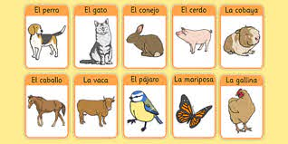 | - Can you interview someone in your class in Spanish?  - Can you record an interview? Create a podcast?

