Goonhavern Primary School- SPANISH
TOPIC: This is Me | YEAR: 3 T2 | STRAND: Spanish

What should I know already? | What will I know by the end of the unit?
- To understand that different languages have different sounds.  - To know and respond to Spanish greetings.  - To understand and respond in Spanish to “What is your name?”  - To understand and respond in Spanish to “How old are you?  - To know Spanish numbers to 10.  - To know Spanish colours.  - To know Spanish words for family members. | To identify two ‘d’ sounds in Spanish.
 | Be able to say in Spanish what we are good at.
 | To know the months of the year in Spanish.
 | To be able to follow instructions in Spanish.
 | To know the Spanish words for body parts.
 | To know the parts of the face in Spanish.
 | To know the parts of the body in Spanish.
 | To write descriptive phrases in Spanish.
School Values
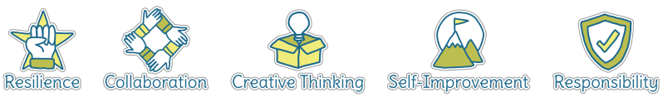
Five Ways to Wellbeing
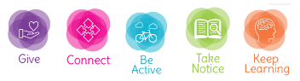

Vocabulary
Months of the Year |  | Parts of the Body
enero | January | pelo | hair
febrero | February | ojo | eye
marzo | March | nariz | nose
abril | April | oido | ear
mayo | May | boca | mouth
junio | June | brazo | arm
julio | July | mano | hand
agosto | August | estómago | stomach
septiembre | September | pierna | leg
octubre | October | pie | foot
noviembre | November | dedo | toe
diciembre | December | cuerpo | body
Soy bueno en... | I am good at...

Image/diagram that helps me to articulate my knowledge/understanding | Investigate!
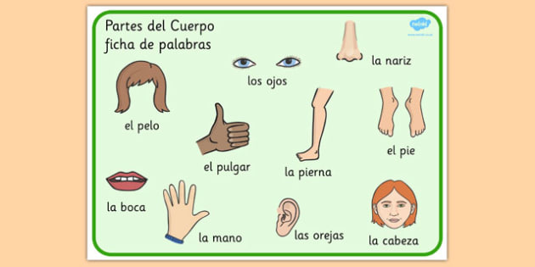 | - Can you play ‘Heads, Shoulders, Knees and Toes’ in Spanish?  - Can you teach ‘Heads, Shoulders, Knees and Toes’ to somebody else in Spanish?  - Can you write a profile for yourself?

