Goonhavern Primary School- SPANISH
TOPIC: Arrival | YEAR: 3 T1 | STRAND: Spanish

What should I know already? | What will I know by the end of the unit?
- Spain is part of Europe.  - Spain is on a map of Europe.  - Spain is in relation to the United Kingdom and how far away it is.  - Many other countries speak Spanish across the globe and give examples. | Understand that different languages have different sounds.
 | Know and respond to Spanish greetings.
 | Understand and respond in Spanish to “What is your name?”
 | Understand and respond in Spanish to “How old are you?
 | Know Spanish numbers to 10.
 | Know Spanish colours.

Vocabulary
Numbers |  | Colours
uno | one | rojo | red
dos | two | verde | green
tres | three | naranja | orange
cuatro | four | azul | blue
cinco | five | amarillo | yellow
seis | six | rosa | pink
siete | seven | blanco | white
ocho | eight | negro | black
nueve | nine | marrón | brown
diez | ten
Buenos días | Good morning | ỉHola! | Hello!
Si | Yes | ỉAdios! | Goodbye!
No | No | Por favor | Please
¿Puedo? | Can I…? | Gracias | Thank you
¿Como te llamas? | What is your name? | ¿Que tal? | How are you?
Me llamo... | My name is?

Image/diagram that helps me to articulate my knowledge/understanding | Investigate!
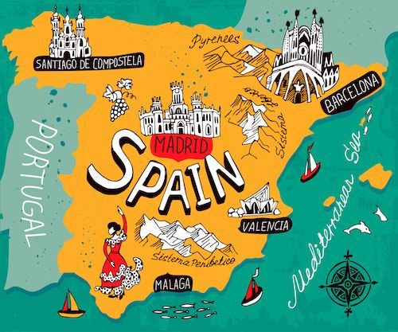 | - Can you use your Spanish language skills to hold a conversation with Elena?  - Can you introduce yourself?  - Do you know your numbers and colours in Spanish?  - Where is Spanish spoken around the world?

