Goonhavern Primary School- SPANISH
TOPIC: Animals and Habitats | YEAR: 4 | STRAND: Spanish

What should I know already? | What will I know by the end of the unit?
- I know the key words for animals in Spanish.  - I can read and use verbs in Spanish.  - I can answer a question in a full sentence.  - I can speak clearly in Spanish.  - I can ask and answer questions in Spanish.  - I can write simple sentences in Spanish. | To know the names of animals in Spanish (consolidate Y3 T3).
 | To be able to describe animals in Spanish.
 | To know the habitats of different animals in Spanish.
 | To know the key words for weather in Spanish.
 | To be able to give the temperature in Spanish.
 | To recognise and pronounce numbers to 40.
School Values

Five Ways to Wellbeing


Vocabulary
Wild Animals |  | Weather (El Tiempo)
Léon | lion | Hace buen tiempo | It is good weather
Oso | bear | Hace mal tiempo | It is bad weather
Foca | seal | Hace frio | It is cold
Mapache | raccoon | Hace calor | It is hot
Girafa | giraffe | Hace mucho calor | It is very hot
Pingüino | penguin | Hace viento | It is windy
Hipopótamo | hippopotamus | Hace sol | It is sunny
Rinoceronte | rhinoceros | Esta nublado | It is cloudy
Tigre | tiger | Llueve | It is raining
Pato | duck | Nieva | It is snowing
Rana | frog | Hay tormenta | There is a storm
 |  | Hay granizo | It is hailing
Habitats
El Oceano | ocean | El Bosque | Forest
La Tundra Ártica | Artic | El Bosque Tropical | Rainforest
La Sabana | Savanna | El Desierto | Desert

Image/diagram that helps me to articulate my knowledge/understanding | Investigate!
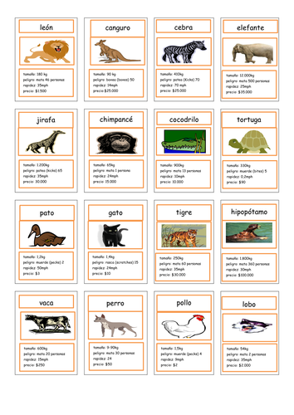 | - Can you create a set of ‘Top Trumps’ for animals in Spanish?  - Can you create posters for two animals that live in different habitats?

