Goonhavern Primary School- SPANISH
TOPIC: Transport | YEAR: 4 T2 | STRAND: Spanish

What should I know already? | What will I know by the end of the unit?
- I can read and use verbs in Spanish.  - I can answer a question in a full sentence.  - I can speak clearly in Spanish.  - I can ask and answer questions in Spanish.  - I can write simple sentences in Spanish | The Spanish phrases for modes of transport.
 | How to write a short passage in Spanish.
 | Spanish phrases for days of the week.
 | Spanish numbers to 39.
 | Have an understanding of different currencies..
 | Be able to show preferences in Spanish.
School Values

Five Ways to Wellbeing


Vocabulary
Means of Transport (Medios de Transporte) |  | Days of the Week
El coche | car | lunes | Monday
El tren | train | martes | Tuesday
El autobús | bus | miércoles | Wednesday
El barco | boat | jueves | Thursday
La motocicleta | motorcycle | viernes | Friday
El avión | plane | sábado | Saturday
El camión | truck | domingo | Sunday
El camión de bomberos | Fire engine
La bicicleta | bicycle
Preferences
Me gusta... | I like...
No me gusta... | I don’t like...

Image/diagram that helps me to articulate my knowledge/understanding | Investigate!
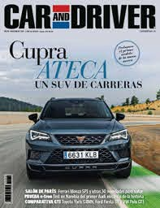 | - Can you create a ‘Top Gear’ type report about a form of transport? Could you film it?  - Make a class magazine about different forms of transport?

