Goonhavern Primary School- SPANISH
TOPIC: Being Active! | YEAR: 4 T3 | STRAND: Spanish

What should I know already? | What will I know by the end of the unit?
Y3 T2:  - Be able to say in Spanish what we are good at.  - To know the Spanish words for body parts.  - To know the parts of the body in Spanish. | Recognise and say parts of the body in Spanish (Y3).
 | Know Spanish words for sports.
 | Respond to questions about favourite sports.
 | Know Spanish words for different foods.
 | Write simple words and phrases.
 | Pupils are to understand and communicate ideas, facts and feelings in speech and writing, focussed on familiar and routine matters, using the knowledge of phonology, grammatical structures and vocabulary.
School Values
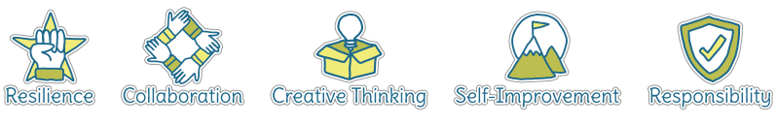
Five Ways to Wellbeing


Vocabulary
Sports |  | Stems
Los Juegos Olimpícos | The Olympic Games | Me gusta_______ | I like __________
El deporte | Sport | Jugar al ________ | To play________
El campeonato | championship
El campeón | champion | Las Frutas
El baloncesto | basketball | Las frutas | fruit
El atletísmo | athletics | La naranja | orange
El ciclísmo | cycling | El limón | lemon
La natación | swimming | La fresa | strawberry
El tenis | tennis | La frambuesa | raspberry
El futbol | football | La cereza | cherry
El rugby | rugby | La manzana | apple
La gímnasia | gymnastics | La banana | banana
La equitación | Horse riding | Las verduras | vegetables

Image/diagram that helps me to articulate my knowledge/understanding | Investigate!
  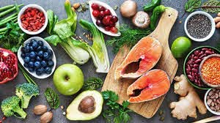 | Tie in with the Olympics and the Euros!  Euros: https://www.uefa.com/uefaeuro-2020/  Olympics: http://tokyo2020.org/en/

