Goonhavern Primary School- Spanish
TOPIC: Un periódico | YEAR: 6 | STRAND: Languages

What should I know already? | What will I know by the end of the unit?
- Can understand and respond to a range of familiar spoken words and short phrases.  - Can join in the re-telling/playing of a familiar story, song, rhyme or poem using gestures or by saying key words and phrases  - Can recognise key sounds and words that rhyme.  - Can match key sounds and words that rhyme.  - Can rehearse and perform short role plays drawing on one topic, with several exchanges and secure pronunciation.  - Is beginning to understand how to form questions/answers independently.  - Can use simple pre-learned words and phrases for routine situations and interaction.  - Can produce short pre-prepared phrases on a familiar topic, with secure pronunciation.  - Can match sound to print, by reading aloud familiar words and phrases.  - Can read and understand a range of familiar written phrases.  - Can identify the overall type of text from its layout, contextual cues and a few familiar words.  - Can use a word list to check the spelling of a word.  - Can use a dictionary or online resource to check the spelling of a word.  - Can write simple words and several short phrases from memory with understandable spelling.  - Can substitute one element in a simple phrase or sentence to vary the meaning. E.g the colour, adjective or noun.  - Can use indefinite articles in singular and plural and definite articles in both singular and plural. Can use a variety of plural nouns, including some irregular ones.  - Can use adjectives (agreement and position) with more confidence. Can use ‘tiene’ (3rd person tener) and está (3rd person estar).  - Can use connectives ‘and’(y), ‘but’ (pero), ‘also’ (además) | Key knowledge | Can produce, with a group, pages of a newspaper showing elements of the language they have learnt at primary school.  Can pronounce correctly the phonic sounds included in the Unit
 | Key Skills | Discuss and reflect on language learning  Use context and previous knowledge to estimate new words  Use language known in one context in another context  Devise questions for authentic use Work in a group
 | Grammar and Structure | Pupils will understand and will be able to use:  -Adverbs to qualify adjectives -Connectives to manipulate language and produce more complex sentences
School Values
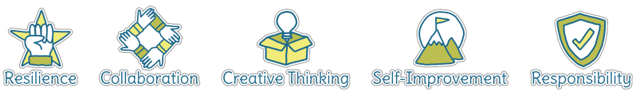
Five Ways to Wellbeing


Vocabulary
Un periódico | newspaper
Artículo de periódico | Newspaper article
El clima | The weather

Image/diagram that helps me to articulate my knowledge/understanding | Investigate!
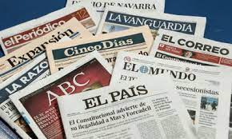 | In a group, create pages for a newspaper that reflect your learning at Goonhavern.  You could assign roles such as editor, sports writer, weather person.

