Goonhavern Primary School- Spanish
TOPIC: Las Estaciones- The Seasons | YEAR: 6 | STRAND: Languages

What should I know already? | What will I know by the end of the unit?
- Can understand and respond to a range of familiar spoken words and short phrases.  - Can join in the re-telling/playing of a familiar story, song, rhyme or poem using gestures or by saying key words and phrases  - Can recognise key sounds and words that rhyme.  - Can match key sounds and words that rhyme.  - Can rehearse and perform short role plays drawing on one topic, with several exchanges and secure pronunciation.  - Is beginning to understand how to form questions/answers independently.  - Can use simple pre-learned words and phrases for routine situations and interaction.  - Can produce short pre-prepared phrases on a familiar topic, with secure pronunciation.  - Can match sound to print, by reading aloud familiar words and phrases.  - Can read and understand a range of familiar written phrases.  - Can identify the overall type of text from its layout, contextual cues and a few familiar words.  - Can use a word list to check the spelling of a word.  - Can use a dictionary or online resource to check the spelling of a word.  - Can write simple words and several short phrases from memory with understandable spelling.  - Can substitute one element in a simple phrase or sentence to vary the meaning. E.g the colour, adjective or noun.  - Can use indefinite articles in singular and plural and definite articles in both singular and plural. Can use a variety of plural nouns, including some irregular ones.  - Can use adjectives (agreement and position) with more confidence. Can use ‘tiene’ (3rd person tener) and está (3rd person estar).  - Can use connectives ‘and’(y), ‘but’ (pero), ‘also’ (además) | Key Knowledge | Can say what the weather is like in different seasons  Can produce a weather forecast using the immediate future  Can use “está” and “es” correctly in the context of geographical features Can pronounce correctly the identified phonic sounds  Can use a bilingual dictionary and understand a longer text about geographical features
 | Key Skills | Estimate meaning, based on prior knowledge  Summarise key points  Work in pairs and develop a dialogue with a partner which can be acted out and written  Use a simple bilingual dictionary
 | Grammar and Structures | Pupils will understand and be able to use: The immediate future using “va a ..”  Masculine/feminine nouns with great confidence  Differences between “es” and “está” “Más” when differentiating between features
School Values
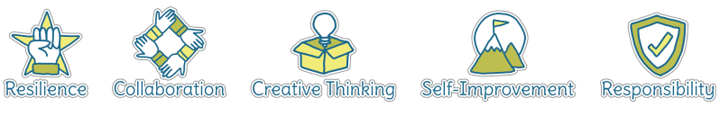
Five Ways to Wellbeing


Vocabulary
Las estaciones | The seasons | enero | January
La primavera | Spring | febrero | February
El verano | Summer | marzo | March
El otoño | Autumn | abril | April
El invierno | Winter | mayo | May
Hace… | It is (hacer- to make) | junio | June
Hace calor | It is hot | julio | July
Hace frío | It is cold | agosto | August
La nieve | snow | septiembre | September
Llover | To rain | octubre | October
La temperatura | The temperature | noviembre | November
El pronóstico | The forecast | diciembre | December
Granizar | To hail | Está frío | It is cold
Está nublado | It is cloudy | El clima | The weather
Está soleado | It is sunny
Está lluvioso | It is rainy
Está caluroso | It is hot

Image/diagram that helps me to articulate my knowledge/understanding | Investigate!
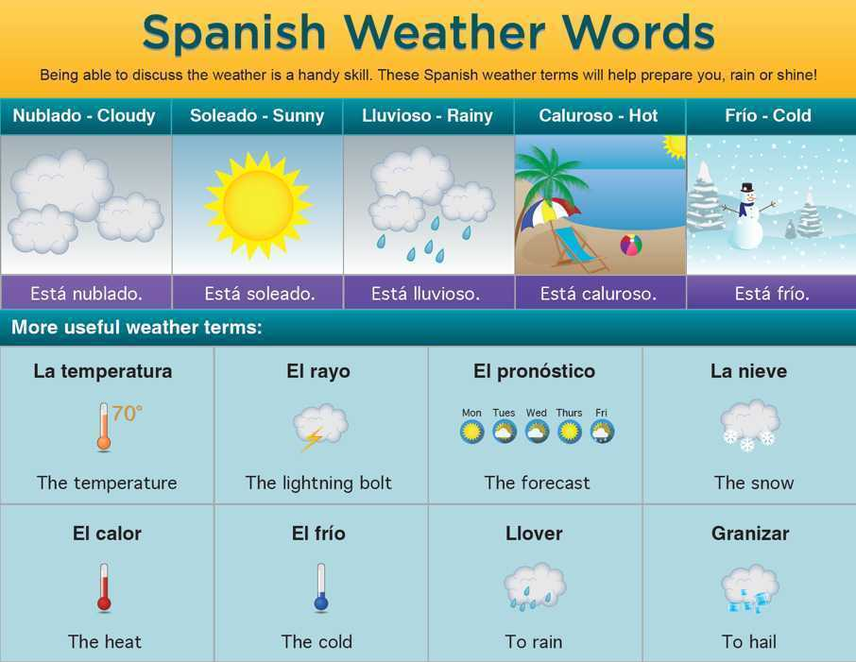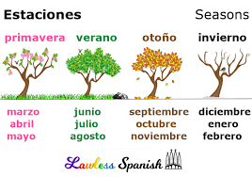 | Create a weather forecast for a newspaper  Act out a TV weather forecast  Video: https://youtu.be/S5zPd2Fy6-M

