Goonhavern Primary School- Spanish
TOPIC: En el café | YEAR: 6 | STRAND: Languages

What should I know already? | What will I know by the end of the unit?
- Can understand and respond to a range of familiar spoken words and short phrases.  - Can join in the re-telling/playing of a familiar story, song, rhyme or poem using gestures or by saying key words and phrases  - Can recognise key sounds and words that rhyme.  - Can match key sounds and words that rhyme.  - Can rehearse and perform short role plays drawing on one topic, with several exchanges and secure pronunciation.  - Is beginning to understand how to form questions/answers independently.  - Can use simple pre-learned words and phrases for routine situations and interaction.  - Can produce short pre-prepared phrases on a familiar topic, with secure pronunciation.  - Can match sound to print, by reading aloud familiar words and phrases.  - Can read and understand a range of familiar written phrases.  - Can identify the overall type of text from its layout, contextual cues and a few familiar words.  - Can use a word list to check the spelling of a word.  - Can use a dictionary or online resource to check the spelling of a word.  - Can write simple words and several short phrases from memory with understandable spelling.  - Can substitute one element in a simple phrase or sentence to vary the meaning. E.g the colour, adjective or noun.  - Can use indefinite articles in singular and plural and definite articles in both singular and plural. Can use a variety of plural nouns, including some irregular ones.  - Can use adjectives (agreement and position) with more confidence. Can use ‘tiene’ (3rd person tener) and está (3rd person estar).  - Can use connectives ‘and’(y), ‘but’ (pero), ‘also’ (además) | Key Knowledge | Can create and perform a role play set in a café  Can follow the recipe for a milkshake Can discuss what they ate and drank in the past using the pretérito  Can pronounce correctly the phonic sounds included in the Unit Skills – Pupils will understand and will be able to use:  -1st and 2nd person singular of pretérito of ‘comer’, ‘beber’ -Connectives to manipulate language and produce more complex sentences
 | Key Skills | Use context and previous knowledge to estimate new words  Use knowledge of words, text and structures to build simple spoken and written passages  Apply phonic knowledge to support reading and writing  Work with a partner
 | Grammar and Structures | Pupils will understand and will be able to use:  - 1st and 2nd person singular of pretérito of ‘comer’, ‘beber’ -Connectives to manipulate language and produce more complex sentences
School Values
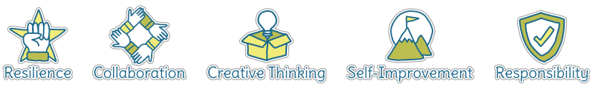
Five Ways to Wellbeing


Vocabulary
El batido | milkshake | chocolate | chocolate
El menú | menu | frambuesa | raspberry
El bocadillo | sandwich | mango | mango
Los helados | Ice creams | pistacho | pistachio
Las bebidas | drinks | La receta | recipe
Bocadillo de queso | Cheese sandwich | limonada | lemonade
Bocadillo de jamón | Ham sandwich | La coca-cola | Coca Cola
Bocadillo de chorizo | Spanish sausage sandwich | La leche | milk
Sabores de helados | Ice cream flavours | El zumo de naranja | orange juice
fresa | strawberry | El jugo de manzana | apple juice
Menta granizada | mint choc chip
limón | lemon
vainilla | vanilla

Image/diagram that helps me to articulate my knowledge/understanding | Investigate!
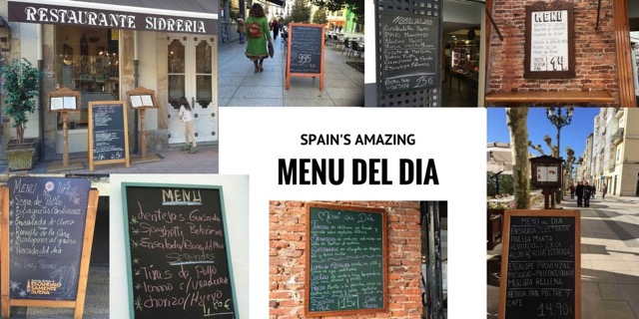  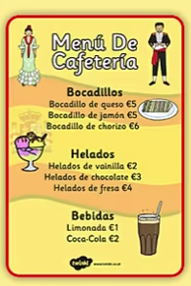  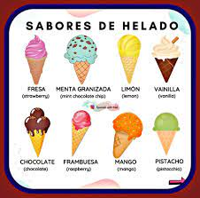 | Follow a recipe for a milkshake.  Make a menu for your own cafe.  Roleplay ordering a sandwich, an ice cream and a drink in a cafe.

